News from the pews
of
Calvary And PEnnsburg
United Church Of Christ
“Together for the Greater Good!”
MAY 2021

Pennsburg United Church of Christ
775 Main Street, Pennsburg PA 18073
phone # 215-679-7513
Church Office: pennsburgucc@gmail.com
Website: www.pennsburgucc.org
Join us on FaceBook! Pennsburg UCC

Sharon Burns, Treasurer

Calvary United Church of Christ
1231 Route 100, Barto PA 19504
phone # 610-652-5023
Church Office: calvaryucc@gmail.com
Website: www.calvaryuccbarto.com
Join us on FaceBook! Calvary UCC Barto
Clothing Ministry: calvarysclosetbarto@gmail.com

Linda Himeback, Treasurer

Heather Spaccarelli, Administrator

The words from a song I learned as a child come to mind when looking at the picture below. It goes like this….I am the church, you are the church, we are the church together! All who follow Jesus, all around the world, Yes we’re the church together! The church is not a building, the church is not a steeple, the church is not a resting place, the church is the people! I am the church, you are the church, we are the church together! All who follow Jesus, all around the world, Yes we’re the church together! We’re many kinds of people, with many kinds of faces, all colors and all ages, too, from all times and places. I am the church, you are the church, we are the church together! All who follow Jesus, all around the world, Yes we’re the church together!
In a world that is dealing with so much, we can still make a difference by being the church in our neighbors, towns, at work…..everywhere we go. We may not understand all that is going on but we

can be the smile, shoulder to lean on, hug, kind word, listener and friend to those we meet. May God’s light shine within you!

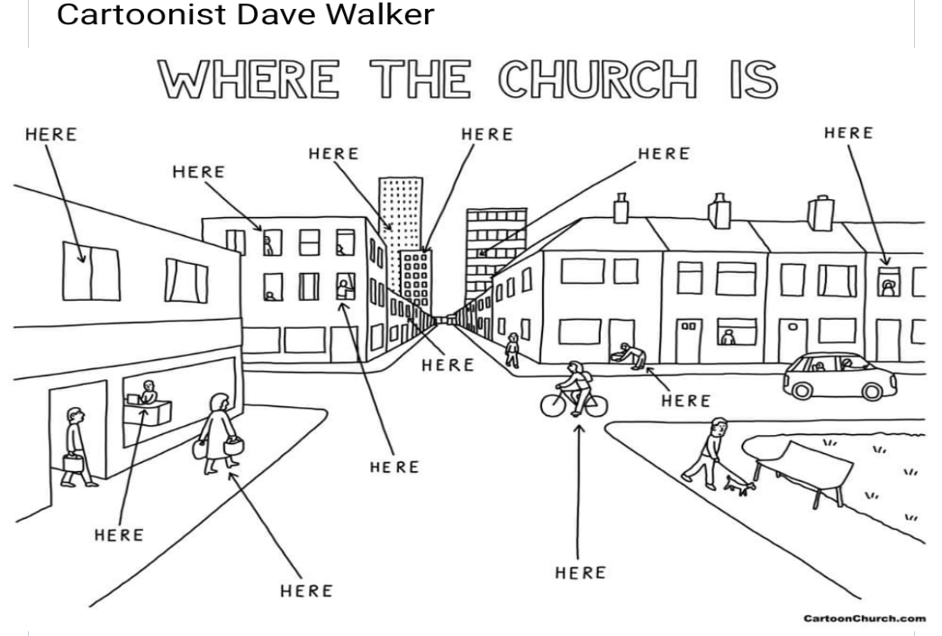

5/17 Pennsburg, Consistory Meeting
5/23 Calvary, Consistory Meeting; following Worship

Pennsburg UCC Consistory
There are currently two vacancies on the Pennsburg UCC Consistory. We have recently had a consistory member resign. The term for this vacancy will be ending this year in December 2021. The second vacancy is for full term, ending in December 2022. If any of our members are interested in joining consistory in either position, please see any current consistory member.
Thank you,
Pennsburg UCC Consistory

2021 Calvary Consistory Officers
President – Harold Albitz
Vice President – Rona Britton
Secretary – Sherry Bauer
Treasurer – Linda Himeback
Elders: Harold Albitz, Sherry Bauer,
Kim Marburger, Marlene Latshaw
Deacons: Rona Britton, Tracey Frey, Becky Crist, Sonya Spotts

2021 Pennsburg Consistory Officers
President – Jane Bernhard
Vice President – Dana Heimbach
Secretary – Paula Sell
Treasurer – Sharon Burns
Team: Jane Bernhard, Jana Butler, Sharon Burns, Danielle Felix, Dana Hiembach, Bill Kurtz, Holly Lash, Scott Mest, Gail Schmoyer,
Paula Sell, Wendy Smedley

Worship begins at 9:30am.
Join us in person or via Facebook Live or Zoom!

No computer or smart phone? No problem! You only need a phone to listen to Worship via Zoom!
Dial: 1-929-205-6099 and when prompted enter the Meeting ID 328 526 4749 and listen to the voice prompts for simple directions.

Pennsburg UCC will host Worship the following dates:
May 2 – The Youth of Pennsburg & Calvary UCC
May 16 – Rev. Meagan McLeod
May 30 – Rev. Meagan McLeod
June 13 – Threefold Blessing

Calvary UCC will host Worship the following dates:
May 9 – Rev. Meagan McLeod
May 23 – Rev. Meagan McLeod
June 6 – Rev. Meagan McLeod
June 20 – Rev. Meagan McLeod

Please note that we will resume singing (while masked) at both churches, and Calvary will be opening all pews, asking you to be respectful by allowing space between yourself and others.

Prayer Chains are ready to pray for you!
Calvary has relaunched our Prayer Chain. If you need prayers for yourself or a loved one, reach out to the church office and we will send it through our Prayer Chain.

The May First Monday Meal will be held on May 3 from 6:00 p.m. to 7:00 p.m. at Pennsburg U.C.C. and is being served by the BPW, they will be serving ham.

Miller-Keystone Blood Drive is scheduled for Thursday May 20 from 2-7pm, held at Bally Mennonite Church. Giving will continue to be by appointment only, due to Covid-19 restrictions. Please contact Rona Britton to make an appointment, or discuss your appointment with her if you have received the Covid-19 vaccine OR have had a positive Covid-19 test over the last 10 months.
Rona can be reached at beachbound923@gmail.com OR 610-367-7878.

* Thank You to everyone that helps promote, volunteer, participates, and gives their time to make events successful! *

Do you have a 2021 graduate in your family?

Help us recognize their achievements by submitting their name, school they are graduating from, and future plans to Heather in either office by May 24th!

Spring Time Spruce Up… Please remove all Christmas decorations from PUCC cemetery as soon as possible. Containers are located at several places on the cemetery for disposing decorations, if you cannot take them with you. We hope that you have noticed the new signs at both 8th Street entrances of the cemetery. Clean up dates are listed on these signs. Please do your part!

Youth Sunday - We will be holding Youth Sunday on Sunday May 2 at Pennsburg UCC with members of the combined Youth Group leading the worship service around the theme of the "Fruits of the Spirt" from Galatians 5:22-26. Please come out and support our youth.

Youth Group - We will be meeting in June. The Youth Group is open to youth of both congregations in First through Twelfth grades. If you have any questions, please see Holly Lash or Wendy Smedley.

Vacation Bible School will be held in-person this year the week of July 18. If anyone would like to help, please contact Wendy at either wsmpucc@aol.com or 610-420-3029.

On-Call Pastors…

Calvary: Rev. MaryEtta Mest. Her email address is mestme@aol.com and phone number is 610-659-2775.

Pennsburg: Rev. Nick Pence. His phone number is
267-374-5691 if you have a Pastoral Emergency.

Rev. Meagan McLeod’s Birthday is coming up, and we will be secretly gathering Birthday Cards for a Shower of Birthday Wishes for her!
If you would like to participate, kindly have your Birthday cards for Meagan turned into Heather by Sunday June 13th!

Calvary Christian Fellowship & Social Ministries News!

- The social ministries and fellowship commission will meet on Thursday, May 13 at 7:00 PM to plan
the upcoming events. All are welcome to attend!

- THANK YOU to everyone who contributed baskets to the raffle and to everyone who purchased tickets. The 1st Spring raffle was a success!

Are you (somewhat) Technically Inclined?
Are you interested in helping with our Facebook Live streaming? Heather is looking for a few people to share the responsibilities and balancing the weight of Sunday morning broadcasts.
Want to help but you’re not available every Sunday morning?
Shaking your head “Yes”? Then this is the perfect opportunity to get involved!
If you would like to help, or want more information, please contact Heather at calvaryucc@gmail.com, or call Calvary’s office.
She is looking forward to hearing from you!

Calvary Altar Flower and Bulletin Sponsors: If you are interested in sponsoring either Altar Flowers or Bulletins for 2021, kindly sign up in the binder located in the greeting area. If you wish to write a check to sponsor flowers, please make it payable to “Tracey’s Flowers” If you choose to write a check for the bulletins, please make it payable to “Calvary UCC” Payments may be placed in the offering plate.

E-mail addresses We would love for you to share your email address with us so you can receive our weekly email! This email includes important information such as upcoming events, changes to office hours, etc. To “opt in” please send an email to pennsburgucc@gmail.com OR calvaryucc@gmail.com with “Mailing List” in the subject line. If you would like to receive the monthly newsletter via email, please send an email to the office with “newsletter” in the subject line.

USAgain CLOTHING BINS at Calvary Thank you to all that help to fill our bins and help to reduce, reuse, and recycle clothing materials! Please keep in mind that once bags are dropped into the collection bins, the church has no access to them. So, if you are wanting to donate items to the Flea Market, or to Calvary’s Closet, please drop your items off at the lower doors. Thank you!! In 2020, despite the pandemic, and the bin closure, we still exceeded our collection amount of 2019! We recycled 36,930 pounds of textiles in 2020!

Aluminum Can Collection/Recycling at Calvary Please bring your bagged aluminum cans to the lower double doors and place them in the cans with the blue lids. Thanks for your support.

Calvary’s Closet… Do you, or someone that you know need a helping hand? Have they been displaced due to a tragedy or victim of a disaster? Maybe rebuilding their lives after a life event or a hardship? Calvary’s Closet is here to help those affected by such events. Open by appointment, and available to help
those within our community. We can provide things such as clothing, linens, household items, and toys. If you have a specific need, please contact us as we may have it available! For questions, inquires for a need, donations or help, please contact us at: CalvarysClosetBarto@gmail.com or the Church office phone number is 610-652-5023, and if Heather is not in the office, she will return the voicemail as soon as possible. “Uniting Communities Through Caring”

Devotional Booklets Available Both PUCC & CUCC have subscribed to the Upper Room Devotional Booklet. Every issue contains 2 months of daily devotionals. There are copies for May/June at both Churches.

Our Daily Bread Devotional for March/April/May is also available, at both CUCC & PUCC thanks to a generous donation from a friend!
Please pick up a copy next time you come to church! Or swing into Calvary’s parking lot and help yourself to a copy in the red pedestal mailbox at the lower double doors, monthly newsletters are available there too!

Notes from the administrator’s desk…

Office hours at Calvary are as follows:
Monday, Wednesday, Friday 4pm – 6pm / Tuesday & Thursday 8:30am – 12:30pm
At this time, Office hours at Pennsburg are Flexible, reach out to Heather if you wish to stop by.

*The JUNE Newsletter Deadline is Monday MAY 24th*

MAY BIRTHDAYS

5/2 Colby Weller
5/3 Peggy Schwenk
5/4 Devan Schmoyer
5/6 Rebecca Marburger
5/9 Courtney Moatz
5/10 Adalynn Conrad
5/12 Trevor Crist
5/13 MaryAnn Galloway
5/16 Joyce Hess, Fred Kroncke,
Andrew Bellesfield, Sharon Tarantino
5/17 Glenn Beard, Zachary Kern
5/20 Victoria Mest, Rodney Miller
5/22 Donna Kroncke
5/23 Kathleen Badman,
Aliviyah Grace Conrad
5/24 Shirley Diehl
5/25 Lori Kern, Debra Royer
5/28 Jenna Marburger
5/29 Christopher Mathias, Samantha Beard, Virginia Mutter, Isaac Royer

*If you have a Birthday during the month and it was not mentioned, or the date is listed wrong, please let the office know. We are working to keep our records updated and your help in this effort is appreciated. Thank you.

May Anniversary’s

5/5 – Sherry & John Haas
5/20 – Joan & Warren Albitz (60 years!)
5/22 – Holly & Irvin Lash
5/24 – Kellie & Daryl Mensch

*If you have an Anniversary during the month and it was not mentioned, or the date is listed wrong, please let the office know. We are working to update our records and your help in this effort is appreciated. Thank you.

- Please hold our future Interim Pastor, Dave Brumbaugh, in prayer as God prepares him
for ministry with us.
- Everyone that has been affected by the Pandemic and illness.
*Please contact the Prayer Chains with any additional Prayer Requests

Carol Huff
315 Bassett Ct.
Limerick, PA 19468
484-932-8629

Mabel Schultz
Frederick Living
2849 Big Rd.
Apt. 2124B
Zieglersville, PA 19492

June Brinckman
The Village of LifeQuest
2100 Cherry Blossom Lane
Quakertown, PA 18951
215-679-7015

Dorothy Keim
Frederick Living
2849 Big Rd.
Apt. 1229
Zieglersville, PA 19492

Grace Grubb
Pennsburg Manor
Room #214A
530 Macoby St.
Pennsburg, PA 18073
215-679-5030

Howard & Barbara Moser
Frederick Living
2849 Big Rd.
Apt. 116
Zieglersville, PA 19492

Bobby Smith
1491 Markley Rd.
Pennsburg, PA 18073
215-679-9350

Emil Schultheisz
120 W. 5th St.
Chestnut Knoll Room 313
Boyertown, PA 19512

Lydia Maurer
502 Main St. Apt. A
East Greenville, PA 18041
215-679-7093

Thelma Borchelt
Frederick Living
2849 Big Rd. Apt. 1302
Zieglersville, PA 19492

Shirley Pursel
134 Concord Dr.
PO Box 155
Hereford, PA 18056-0155
215-679-5644

Janet Kulp
Amity Place #123
139 Old Swede Rd.
Douglassville, PA 19518

Randy & Beverly Reinert
809 Holly Dr.
Green Lane, PA 18054-2022
215-234-8208

Paul Schollenberger
P.O. Box 141
New Berlinville, PA 19545-0141

Peggy Schwenk
Parkhouse Nursing & Rehab Center
1600 Black Rock Rd.
Room #224
Royersford, PA 19468

Lillian Miller
3711 Hershey Ct.
Whitehall, PA 18052-3369

Betty Althouse
159 Main St.
Pennsburg, PA 18073
215-679-8179

Eileen Haring
1828 Big Rd.
Gilbertsville, PA 19525

George Meck
c/o Cindy Palan
1805 Rhawn St.
Philadelphia, PA 19111
215-280-8368

Roy Moll
529 Adams St.
Red Hill, PA 18076-1205
215-679-6650

Calvary’s Corner
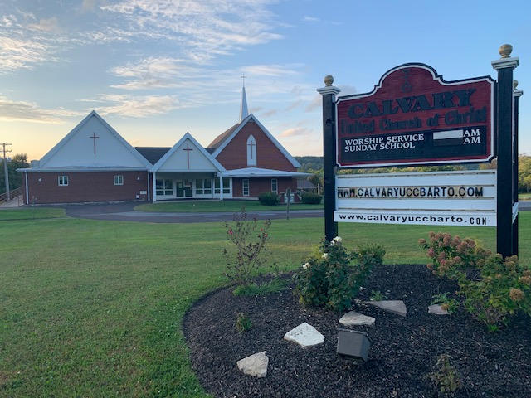
Hooray for May! I am sure we are all looking forward to warmer days and outdoor fun. Calvary and Pennsburg are blessed to continue to worship together with Rev. Meagan McLeod while awaiting the arrival of Rev. Dave Brumbaugh on July 1st. We are also looking forward to another service led by Threefold Blessing on June 13th at Pennsburg. Please note that we will resume singing (while masked) at both churches, and Calvary will be opening all pews, asking you to be respectful by allowing space between yourself and others.
Kim, Fred and the Property Commission continue to keep up with maintenance and repairs at Calvary. Both the downstairs kitchen and ladies room faucets have been replaced due to leaking. Outlets in the Fellowship Hall kitchen have been tripping the breaker. Conrad will be coming out to look into the problem and also check out the noisy men’s room fan. Dierolf has informed us that the sensor in the water tank UV light unit is bad, and the unit is out of date. The unit will be replaced, taking care of the problem with the sensor.
Thank you, Becky, for organizing the prayer chain. The links have been connected. If you have a prayer concern, please contact the church office.
We are still awaiting results from the audit done by the conference, but they did share that our books and checks and balance systems are well organized. Results will be shared when we get the report. Financial statements will be emailed or mailed in spring, summer and fall. You should be receiving the spring statement shortly. Thank you, Linda, for keeping us organized and informed.
Thank you to all who baked, sorted, priced, donated items and precious time for our Spring Flea Market, Bake Sale and Basket Raffle. Rona and Marlene reported that we broke our record, having the biggest event ever! Even though we are not holding our meal fundraisers, the flea markets, pop up’s, clothing sales, and bake sales are keeping our fundraiser budget in good standing. Thank You!!!
Rona also shared that Calvary continues to be a strong presence in our community through our outreach ministries. They were able to donate 2 box vans full of items for The Ann Frances Outreach Foundation, an organization that helps homeless get back on their feet and in homes. If you are in need, or know someone in need, please contact Calvary. We are blessed to be able to provide clothing and household items to those in need. Thank you for your continued support. Calvary continues to remain strong due to your generosity through giving, (in person, online and mail), your donations for the flea market and items for our outreach program, and the time members give to keep events at Calvary going. Our Calvary family and friends are Awesome! Thank you so very much! The people of Calvary ARE Calvary, we are the church because of you!
May you feel the Lord’s blessings every day, Your consistory,
Harold Albitz, Kim Marburger, Sherry Bauer, Marlene Latshaw, Rona Britton, Becky Crist, Sonya Spotts and Tracey Frey.

