News from the pews
of
Calvary And PEnnsburg
United Church Of Christ
“Together for the Greater Good!”
JUNE 2021

Pennsburg United Church of Christ
775 Main Street, Pennsburg PA 18073
phone # 215-679-7513
Church Office: pennsburgucc@gmail.com
Website: www.pennsburgucc.org
Join us on FaceBook! Pennsburg UCC

Sharon Burns, Treasurer

Calvary United Church of Christ
1231 Route 100, Barto PA 19504
phone # 610-652-5023
Church Office: calvaryucc@gmail.com
Website: www.calvaryuccbarto.com
Join us on FaceBook! Calvary UCC Barto
Clothing Ministry: calvarysclosetbarto@gmail.com

Linda Himeback, Treasurer

Heather Spaccarelli, Administrator

As we enter the Summer season of 2021, we prepare for changes all around us. Activities that were so “normal” to us are slowly resuming, as we continue to see Covid-19 cases decline. This is an exciting time of year with watching the seasons change. Flowers in bloom, vehicles covered in what seems like never-ending pollen, warm weather, amazing sunsets, children playing in the park, and additional travelers on the roads, are all signs of change. Truly people coming out of hibernation after the longest “2 weeks” (to flatten the curve) which lasted more than a year. A year that will not soon be forgotten. Graduations, family picnics, celebrations, vacations, and more will fill our calendars over the next
several weeks.

Next, we will have another season of change, this time within our church walls. As we say “see you later” to our (main) Supply Pastor from over the last 8 months, Reverend Meagan McLeod. She has been such an important "stepping stone", and a HUGE blessing, with the transition of Calvary and Pennsburg sharing ministry, which we will continue to do in this season of change. Reverend Meagan will lead us in Worship through the end of June, with the exception of Sunday June 20th, of which Rev. Martha Kriebel will be filling in.

What happens at the conclusion of June you ask? On Thursday July 1, 2021 we will welcome Pastor Dave Brumbaugh to Calvary UCC & Pennsburg UCC. Pastor Dave will lead us in Worship on Sunday July 4^{th.} We realize that because Sunday July 4th is a holiday, that many of you may not be able to attend Worship due to family gatherings and vacations.
Facebook Live and Zoom options will be on-going so you can join us virtually from wherever you find yourself, if you are not able to attend in person.
Change can come with a mix of emotions depending on whom you ask. Some experience excitement, while others may be fearful, have anxiety, or even stress. As we continue to Worship together, and share ministry, we will continue to see that our people make the church, and the church does not make the people. Even through a global pandemic, we have continued to thrive together, and grow; Together for the greater good.
May this season of change continue to be blessed,
Your Administrator,
Heather Spaccarelli

6/21 Pennsburg UCC, Consistory Meeting
(Date to be determined) Calvary UCC, Consistory Meeting

Pennsburg UCC Consistory
There are currently two vacancies on the Pennsburg UCC Consistory. We have recently had a consistory member resign. The term for this vacancy will be ending this year in December 2021. The second vacancy is for full term, ending in December 2022. If any of our members are interested in joining consistory in either position, please see any current consistory member.
Thank you,
Pennsburg UCC Consistory

2021 Calvary Consistory Officers
President – Harold Albitz
Vice President – Rona Britton
Secretary – Sherry Bauer
Treasurer – Linda Himeback
Elders: Harold Albitz, Sherry Bauer,
Kim Marburger, Marlene Latshaw
Deacons: Rona Britton, Tracey Frey, Becky Crist, Sonya Spotts
2021 Pennsburg Consistory Officers
President – Jane Bernhard
Vice President – Dana Heimbach
Secretary – Paula Sell
Treasurer – Sharon Burns
Team: Jane Bernhard, Jana Butler, Sharon Burns, Danielle Felix, Dana Hiembach, Bill Kurtz, Holly Lash, Scott Mest, Gail Schmoyer,
Paula Sell, Wendy Smedley

On-Call Pastors…

Calvary: Rev. MaryEtta Mest. Her email address is mestme@aol.com and phone number is 610-659-2775.

Pennsburg: Rev. Nick Pence. His phone number is
267-374-5691 if you have a Pastoral Emergency.

Worship begins at 9:30am.
Join us in person or via Facebook Live or Zoom!

No computer or smart phone? No problem! You only need a phone to listen to Worship via Zoom!
Dial: 1-929-205-6099 and when prompted,
enter the Meeting ID 328 526 4749 and listen to the voice prompts for simple directions.

Pennsburg UCC will host Worship on:
June 13 – Rev. Meagan McLeod
June 27 – Rev. Meagan McLeod
July 11 – Pastor Dave Brumbaugh
July 25 – Pastor Dave Brumbaugh

Calvary UCC will host Worship on:
June 6 – Rev. Meagan McLeod
June 20 – Rev. Martha Kriebel
July 4 – Pastor Dave Brumbaugh
July 18 – Pastor Dave Brumbaugh

Updated COVID-19 Precautions at Pennsburg UCC & Calvary UCC
In accordance with new CDC guidelines and recommendations, starting Sunday, June 13th, both Pennsburg UCC & Calvary UCC will no longer be requiring masks for those that have received vaccination for COVID-19. It is still recommended for those without vaccination to continue to wear a mask. In addition, all pews are now open for seating. However, regardless of vaccination status, we ask that you maintain social distancing.

Prayer Chains are ready to pray for you!
If you need prayers for yourself or a loved one, reach out to the church office and we will send
it through the Prayer Chain.

The June “First Monday Meal” will be held on June 7, from 6:00 p.m. to 7:00 p.m. at Pennsburg U.C.C. It will be served by Lechner & Stauffer and catered by Tosco's. The menu is: Salad, bread, baked ziti and homemade dessert.

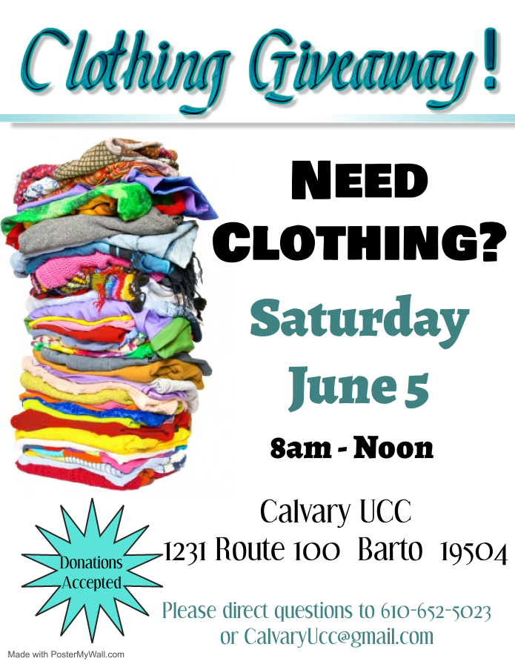

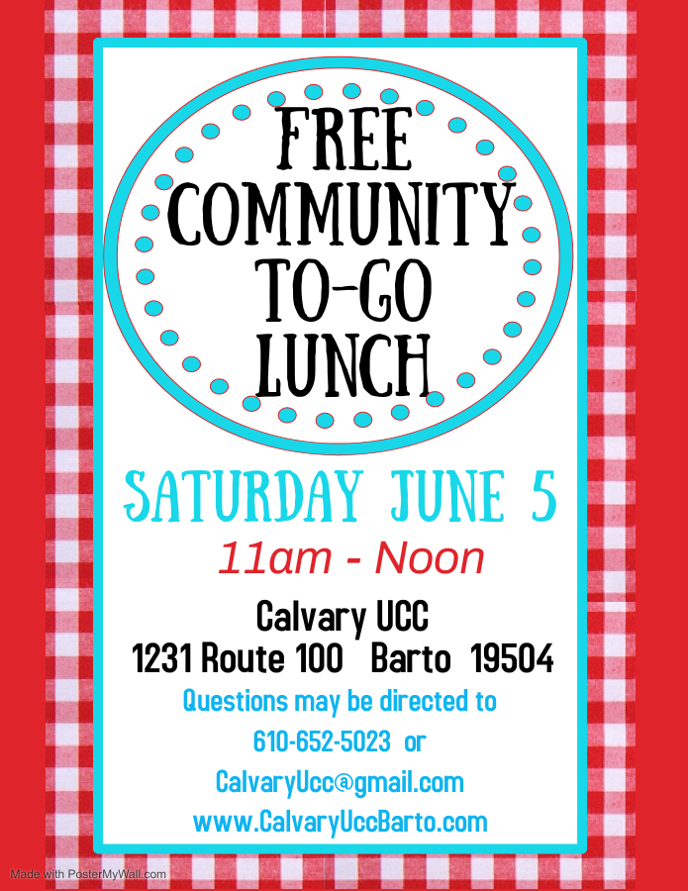

* Thank You to everyone that helps promote, volunteer, participates, and gives their time to make events successful! *

THANK YOU to our youth and leaders who led us in worship on May 2.
Great job everyone!

Youth Group - We will be meeting in June. The Youth Group is open to youth of both congregations in First through Twelfth grades. If you have any questions, please see Holly Lash or Wendy Smedley.

Vacation Bible School will be held at Pennsburg U.C.C. in cooperation with St. Mark's Lutheran Church from Sunday, July 18 through Thursday, July 22 from 6:30 p.m. to 8:00 p.m. The theme is Group Publishing's "Rocky Railway – Jesus’ Power Pulls Us Through". VBS is available to children from 2 years of age through just completed 6th grade. Please register your child using the registration form (attached to this newsletter) or one available at either Pennsburg U.C.C. or Calvary U.C.C. If you forget to pre-register, you may register on the first night of VBS. At this time, we will be requiring masks and will be holding VBS both inside and outside while observing social distancing. Please have your child bring a beach towel labeled with their name. The towels will be used for them to sit on during our outside activities.
Snack donations are welcome, we are serving individually packaged snacks this year. We are looking specifically for: individually packaged granola bars, Oreo cookies, pretzel sticks, Twizzlers, juice boxes/pouches and bottles of water. These may be placed in the kitchen at Pennsburg U.C.C. We are also looking for volunteers. If you are available to help, or have any questions, please see or call Wendy Smedley at either 610-420-3029 or wsmpucc@aol.com

Rev. Meagan McLeod’s Birthday is coming up, and we will be secretly gathering Birthday Cards for a Shower of Birthday Wishes for her!
If you would like to participate, kindly have your Birthday cards for Meagan turned into either office by Sunday June 6th!

Thanks ♥
♥Love
Offering of

To show our appreciation and gratitude to Rev. Meagan, we will be presenting her with a gift on the last Sunday that she will be leading us in Worship, Sunday June 27th. The gift that makes the most sense is to give her money, as she is constantly in transit serving the Community as a Pastor and it can be used anywhere in her travels for what she may need.
If you would like to contribute to this collection, please see Sherry Bauer at Worship, or you may mail or leave your donation at either office, please ensure it is labeled
“Rev. Meagan’s Love Offering” and that it is received by Sunday June 20th.
Any questions may be directed to Sherry Bauer, Sharon Burns, or Heather Spaccarelli.

Something Has Been Missing...
Remember the sound of our church bell ringing every Sunday morning ...
it is a lovely sound and it has been missed.
Aidan Lash took over the Bell Ringer duty but now it is time to pass this “duty”’ on to someone new. Aidan will be going off to college in August. He is willing to teach the bell ringing technique to someone soon.
If you are interested, please contact Kathy Badman or Sharon Burns.

VOLUNTEERS ARE NEEDED on Saturday, June 5 from 10:00 AM – 1:00 PM to prepare and distribute the community meal and to pack up the left-over clothing. Thank you for your continued support of our outreach ministries.

Calvary’s Closet… Here we grow again! Calvary’s Closet is constantly expanding our
“network” within the community, and we are looking for a few things to help continue
this great success of serving the community!
We are making some exciting changes to the indoor flea market and to Calvary’s Closet.
If you have any of the following items that you wish to donate to the church, please see Rona or Heather to set up a time to bring it by the church, or if needed, picked up.
Items that we are currently looking for include, (but not limited to) …
Bookshelves, Free-standing coat racks, Sturdy garment & clothing racks,
Folding tables, and Card Tables.
With yard sale season upon us, we are always keeping our eyes open for display and storage options, Thank You for helping us serve the community!

Calvary Altar Flower and Bulletin Sponsors: If you are interested in sponsoring either Altar Flowers or Bulletins for 2021, kindly sign up in the binder located in the greeting area. If you wish to write a check to sponsor flowers, please make it payable to “Tracey’s Flowers” If you choose to write a check for the bulletins, please make it payable to “Calvary UCC” Payments may be placed in the offering plate.

Are you (somewhat) Technically Inclined?
Are you interested in helping with our Facebook Live streaming? Heather is looking for a few people to share the responsibilities and balancing the weight of Sunday morning broadcasts.
Want to help but you’re not available every Sunday morning?
Shaking your head “Yes”? Then this is the perfect opportunity to get involved!
If you would like to help, or want more information, please contact Heather at calvaryucc@gmail.com, or call Calvary’s office. She is looking forward to hearing from you!

FOR SALE!

GT 235 (2001) with a 42” Deck, Green. Works. Moderate Cosmetic Issues.
Owner’s manual available.
Asking $400
(The riding mower has been used in the Pennsburg UCC Cemetery, and is no longer needed since a landscape service now maintains the grounds.)
Please Contact Donna Falk, 215-679-5933 if interested.

Church News Box at Calvary
This little mailbox on a red pedestal holds copies of monthly newsletters, calendars of events, daily devotional books, and more! If you pick up your newsletter in person, you are invited to pick up your newsletters from this box if you are not able to pick it up while attending Worship.

Just because this mailbox is at Calvary, it is open to BOTH congregations, and also the public!
The red pedestal mailbox is located at the lower double doors.

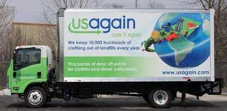

USAgain CLOTHING BINS at Calvary Thank you to all that help to fill our bins and help to reduce, reuse, and recycle clothing materials! Please keep in mind that once bags are dropped into the collection bins, the church has no access to them. So, if you are wanting to donate items to the Flea Market, or to Calvary’s Closet, please drop your items off at the lower doors. Thank you!!

Aluminum Can Collection/Recycling at Calvary Please bring your bagged aluminum cans to the lower double doors and place them in the cans with the blue lids. Thanks for your support.

Notes from the administrator’s desk…

Office hours at Calvary are as follows:
Monday, Wednesday, Friday 4pm – 6pm
Tuesday & Thursday 8:30am – 12:30pm
At this time, Office hours at Pennsburg are Flexible, reach out to Heather if you wish to stop by.

*The JULY Newsletter Deadline is Noon on Monday JUNE 26th*

- Matthew James Frey graduated from the Pennsylvania College of Technology in Williamsport on May 15, 2021 with a Bachelor of Science, Residential Construction Technology and Management Degree. Matthew made Dean's list every semester, and was able to travel out of state to work on rebuilding a home destroyed in a storm while in school. He has accepted a position with Terra Structures as a Jr Project Manager, a company under Haines and Kibblehouse who he interned with during the summer. Matthew is the son of Michael and Tracey, and brother to Timothy Frey.

- Jason Mercando, the son of Lisa and Paul Mercando and the grandson of Donna and Fred Kroncke, graduates from The Philadelphia College of Osteopathic Medicine, as a Doctor of Osteopathic Medicine on May 24, 2021. Jason is beginning his residency at St. Mary Mercy Livonia Hospital in Livonia, MI, with the intention of pursuing a career as a doctor specializing in anesthesia.

- Taylor Kallie Smith will graduate with the UPHS Class of 2021 and will be continuing her education at Montgomery County Community College in the fall. Taylor is the daughter of Todd and Lisa Smith of PUCC.

- Sarah Mae Cleary will graduate from Upper Perkiomen High School. She will be going to Lock Haven University, to study Special Education. Sarah is the granddaughter of Ginny & Bud Wisler

- Aidan Lash, is a senior and will be graduating from Upper Perkiomen High School on June 10. He plans to attend Penn State, University Park to major in civil engineering. He is the son of Holly and Irv Lash.

- Becky Marburger graduated from Alvernia University of Reading, Pennsylvania on Saturday May 15th with her Doctorate in Physical Therapy. This degree was earned after completing 3 years of graduate courses including 34 weeks of full-time clinical internships in the hospital and outpatient settings. Becky has plans to work locally in both the inpatient and outpatient care settings to provide rehabilitation to maximize her patient's function and improve their overall quality of life. Becky would like to thank the Calvary UCC community for their continuous support along this journey. Becky is the daughter of Kim Marburger, and sister to Jenna Marburger.

- Maiken Mest received her Licensed Practical Nurse (LPN) degree from Falcon Institute of Health and Science. Maiken graduated from Falcon on January 22, 2021 and will be taking her board exam in June. She is currently doing agency work is looking forward to the next step of becoming a Registered Nurse (RN).

- Victoria Hope Mest graduated from Boyertown Area Senior High School on June 4, 2021. Tori loves art, digital animation, and gaming and plans to pursue a career that blends the three. Although Tori does not have plans to attend college at this time, she is considering taking online courses to keep her on her career path.

June BIRTHDAYS

6/1 Heather Reigner & Kira Reigner
6/4 Thomas Kunkle, Ann Long,
Paula Sell, & Donald Nuss
6/12 Katelyn Oister
6/13 Amy Shafer & JoAnn Longacre
6/14 Donna Himmelberger
6/15 Raymond Koffroth
6/16 Lori Hawkins & DeeDee Smith
6/18 Shirley Neiman & Ryan Ruth
6/24 Alyssa Crist & Bill Kurtz
6/26 Jaxon Huff & Jace Stofflet
6/27 Sharon Haas & Eileen Koffroth
6/29 Drew Haring & Barbara Nuss
6/30 Dale Lathaw & Dean Latshaw

*If you have a Birthday during the month and it was not mentioned, or the date is listed wrong, please let the office know. We are working to keep our records updated and your help in this effort is appreciated. Thank you.

June Anniversaries

6/2 – Marlene & Dean Latshaw
&
Jennifer & David Bickley
6/14 – Peggy & Daniel Moser
6/17 – Barbara & Anthony Parestis

*If you have an Anniversary during the month and it was not mentioned, or the date is listed wrong, please let the office know. We are working to update our records and your help in this effort is appreciated. Thank you.

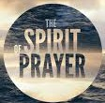
- Please hold our future Interim Pastor, Dave Brumbaugh, in prayer as God prepares him
for ministry with us.
- Everyone that has been affected by the Pandemic and illness.
*Please contact the Prayer Chains with any additional Prayer Requests

Carol Huff
315 Bassett Ct.
Limerick, PA 19468
484-932-8629

Mabel Schultz
Frederick Living
2849 Big Rd.
Apt. 2124B
Zieglersville, PA 19492

June Brinckman
The Village of LifeQuest
2100 Cherry Blossom Lane
Quakertown, PA 18951
215-679-7015

Dorothy Keim
Frederick Living
2849 Big Rd.
Apt. 1229
Zieglersville, PA 19492

Grace Grubb
Pennsburg Manor
Room #214A
530 Macoby St.
Pennsburg, PA 18073
215-679-5030

Howard & Barbara Moser
Frederick Living
2849 Big Rd.
Apt. 116
Zieglersville, PA 19492

Bobby Smith
1491 Markley Rd.
Pennsburg, PA 18073
215-679-9350

Emil Schultheisz
120 W. 5th St.
Chestnut Knoll Room 313
Boyertown, PA 19512

Lydia Maurer
502 Main St. Apt. A
East Greenville, PA 18041
215-679-7093

Thelma Borchelt
Frederick Living
2849 Big Rd. Apt. 1302
Zieglersville, PA 19492

Shirley Pursel
134 Concord Dr.
PO Box 155
Hereford, PA 18056-0155
215-679-5644

Janet Kulp
Amity Place #123
139 Old Swede Rd.
Douglassville, PA 19518

Randy & Beverly Reinert
809 Holly Dr.
Green Lane, PA 18054-2022
215-234-8208

Paul Schollenberger
P.O. Box 141
New Berlinville, PA 19545-0141

Peggy Schwenk
Parkhouse Nursing & Rehab Center
1600 Black Rock Rd.
Room #224
Royersford, PA 19468

Lillian Miller
3711 Hershey Ct.
Whitehall, PA 18052-3369

Betty Althouse
159 Main St.
Pennsburg, PA 18073
215-679-8179

Eileen Haring
1828 Big Rd.
Gilbertsville, PA 19525

George Meck
c/o Cindy Palan
1805 Rhawn St.
Philadelphia, PA 19111
215-280-8368

Roy Moll
529 Adams St.
Red Hill, PA 18076-1205
215-679-6650

Calvary’s Corner
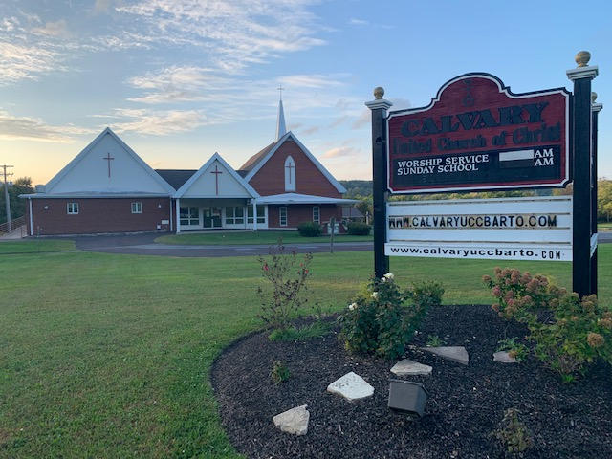
June is here, the month that Summer officially begins. As we look forward to vacation time, getaways, and summer fun, we wish to remind you that our church services continue to be available for viewing on Facebook and Zoom. Please contact the church office if you have any questions. We look forward to seeing you in person or online throughout the summer. Please note that we have resumed singing at both churches, and pews are also open, we are asking you to be respectful by allowing space between yourself and others.
The countdown is on! Pastor David Brumbaugh will be joining us July 1^{st.} We are very excited about the arrival of our designated Interim Pastor. Please feel free to contact the church to speak with Pastor Dave if you have a pastoral need. We will be planning a welcome event in the future as restrictions are lifted, so please introduce yourself and wear a provided name tag so Pastor Dave can begin to feel welcomed at our Churches as he gets to know us.
Rona shared that the latest clothing sale and the blood drive at Bally were a great Success! Once again, we have been able to fill a large van for The Ann Frances Outreach Foundation. If you are in need or know someone in need, please contact Calvary. We are blessed to be able to provide clothing and household items to those in need through our community and outside areas. Thank you to all who work endless hours to pull together our clothing and flea market sale!
Upper Perks Make Music event is June 21st. Pennsburg UCC one of the locations to hear music from noon till 8:45 pm. We would like to offer free water to those who attend and would like volunteers to be present for an hour or so, working along with Pennsburg. Please contact the church office if you can help. Thank you!!!
Rona has ordered a new battery and pads for our A.E.D. unit, and will install them as soon as they arrive to keep our unit up to date. Kim reported that Terry Conrad has cleaned the fans in the men’s bathrooms, and looked at the kitchen outlets. The UV light unit is still on order and will be installed when it comes in. We have also rekeyed the church. Church keys are now numbered and accounted for using a form to sign out and receive returned keys as approved by the consistory.
Tracey Frey is stepping down as the Christian Education director after many years of service. Sonya Spotts has graciously stepped up to be our Christian Education liaison going forward as we create a new Christian Education program, working jointly with Pennsburg and Pastor Dave. Thank you, Sonya!
Thank you for your continued support and generous giving in person, online and mail. Our Calvary family is Awesome, and keeps Calvary strong!
May you feel the Lord’s blessings every day,
Your consistory Harold Albitz, Kim Marburger, Sherry Bauer, Marlene Latshaw, Rona Britton, Becky Crist, Sonya Spotts and Tracey Frey.
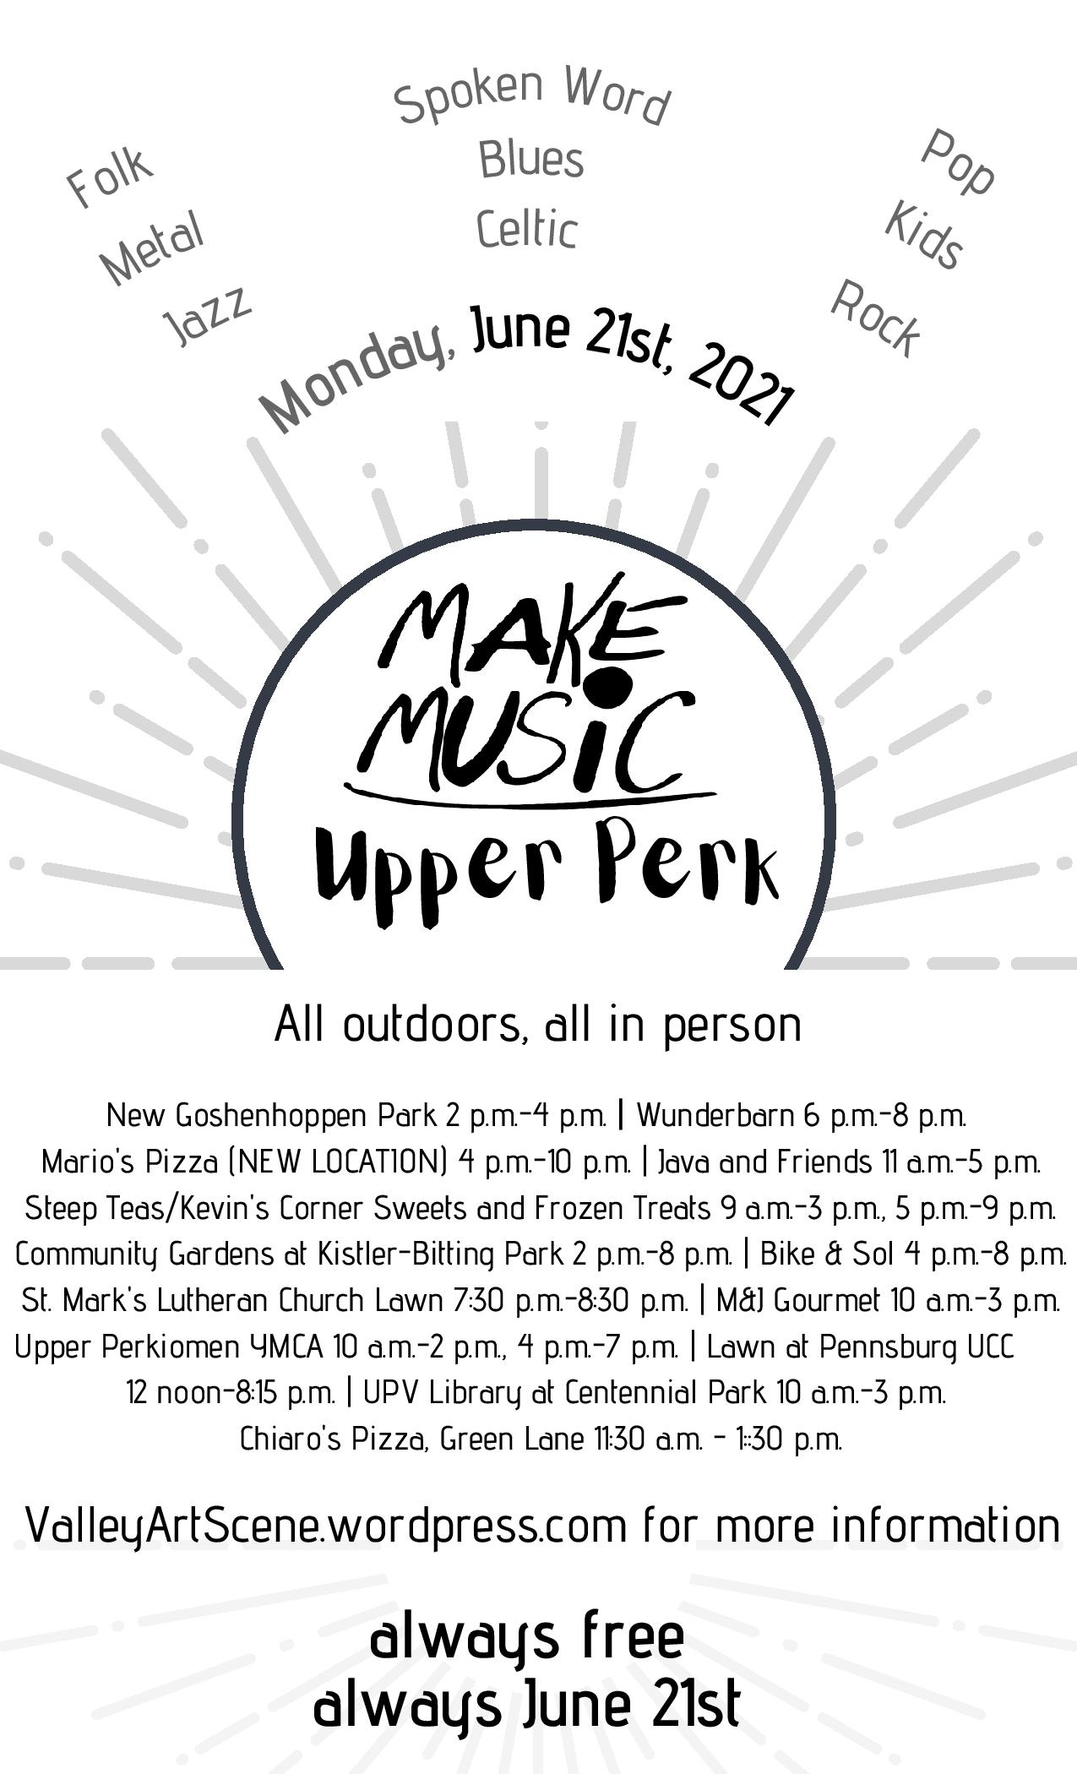

St. Mark’s Lutheran Church / Pennsburg U.C.C.

VACATION BIBLE SCHOOL
July 18 – July 22, 2021
Sunday - Thursday
6:30 – 8:00 p.m.
(Sunday Registration – 6:15 p.m.)
Note: Children may leave earlier, if
necessary, with parent/guardian.

**Location: Pennsburg United Church of Christ
775 Main Street
Pennsburg, PA 18073

“Rocky Railway – Jesus’ Power Pulls Us Through”
Children ages 2 to just completed 6th grade are invited to participate.
Children age 3 or under must be accompanied by an adult.
Donations of juice boxes or pouches, bottles of water and pre-packaged snacks. Donations can be dropped off just before or during Vacation Bible School. Adults who would like to help out are always welcome! Children are urged to dress comfortably and wear a mask. Social distancing will be observed and children will be urged to sit with family/household members. Please bring a beach towel per child.

Please complete the attached Enrollment Form and return to St. Mark’s, attention Dawn or Pennsburg
U.C.C., attention Wendy as soon as possible to reserve a spot.
ST. MARK’S / PENNSBURG U.C.C. VBS ENROLLMENT FORM
Name__________________________ Age________ Birth Day___________
Address________________________________________________________
Phone Number_______________________ Grade Completed_______________
Parent’s Names___________________________________________________
Who May Pick Up Your Child?_________________________________________
Emergency Contact Name(s)__________________________________________
Emergency Contact Phone #(s)________________________________________
Food Allergies____________________________________________________
Other Helpful Information___________________________________________
_______________________________________________________________
Do You Have A Church Home? Yes_______ No________
Comments_______________________________________________________

I give my permission for ___________________________________ to attend Rocky Railway VBS, July 18 to 22, 2021. In the event of medical emergency, I authorize VBS Staff to seek medical attention for my child, I will assume responsibility for any/all resultant expense. Every attempt will be made to notify the parent or emergency contact first.
__________________________________
Parent/Guardian Signature & Date

