The hands & feet of calvary
United Church Of Christ
January 2023
1231 Route 100, Barto PA 19504
phone # 610-652-5023
Church Office: calvaryucc@gmail.com Website: www.calvaryuccbarto.com
Clothing & Outreach Ministry: calvarysclosetbarto@gmail.com
Join us on FaceBook! Calvary UCC Barto

Dave Brumbaugh, Pastor
Heather Spaccarelli, Administrator
Becky Crist, Consistory President
Linda Himeback, Treasurer

___________________________________

1/22 Consistory Meeting, Following Worship

2023 Calvary Consistory Officers

President – Becky Crist
Vice President – Rona Britton
Secretary – Sherry Bauer
Treasurer – Linda Himeback

Elders: Harold Albitz, Sherry Bauer, Kim Marburger, Marlene Latshaw
Deacons: Rona Britton, Tracey Frey, Becky Crist, Sonya Spotts, Linda West

Pastor Dave Brumbaugh - Worship begins at 9:30am... unless otherwise noted!
Join us in person or via Facebook Live or Zoom!

No computer or smart phone? No problem! You only need a phone to listen to Worship via Zoom!
Dial: 1-646-558-8656 and when prompted, enter the Meeting ID 913 8085 8414 and listen to the voice prompts for simple directions. If you are asked for a password/passcode, enter 848423.

January 2023

JANUARY 1 – First Sunday After Christmas
(Guest Preaching: Rev. Elmer Reinhold)

JANUARY 8 – Epiphany Sunday
Ephesians 3:1-12 Matthew 2:1-12
Message “Magi Gifts”

JANUARY 15 – Second Sunday of Epiphany
1 Corinthians 1:1-9 John 1:29-42
Message “What Do Names Mean?”

JANUARY 22 – Third Sunday of Epiphany
1 Corinthians 1:10-18 Matthew 4:12-22
Message “The Beginning…”

JANUARY 29 – Fourth Sunday of Epiphany
Micah 6:1-8 Matthew 5:1-12
Message “O How Blessed…!”

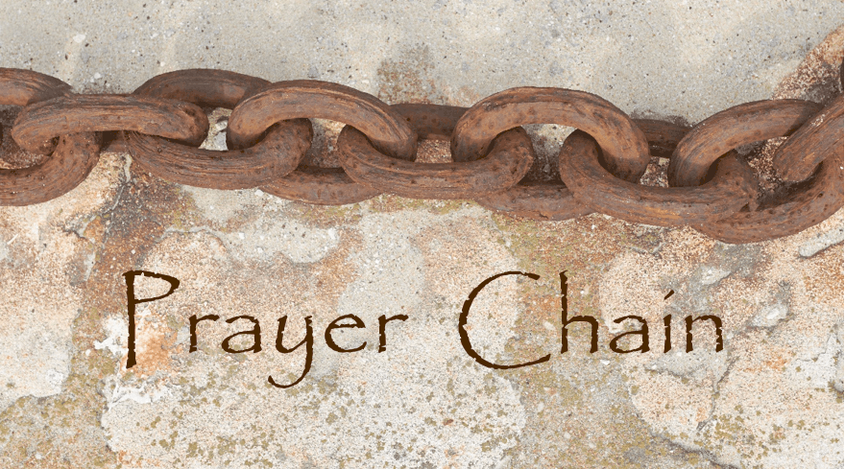
The Prayer Chain is ready to pray for you!
If you need prayers for yourself or a loved one, reach out to Pastor Dave, or the church office and we will send the request through the Prayer Chain.

25₵ Sale & Indoor Flea Market! On Saturday January 21, from 8am – 11am, explore hundreds of items at our locally famous 25₵ Sale upstairs, and then downstairs check out our incredible Indoor Flea Market.

- Want to Volunteer? Please see Kim Marburger if you are able to help unpack boxes of clothing for the 25₵ sale on Wednesday January 18th and/or Thursday January 19th from 4-7pm

Lunch Bunch! Join us for a lunchtime gathering, at a local restaurant, for conversation, food, and fellowship! Everyone is welcome to attend, just sign up (fellowship board on the ramp) so that the selected restaurant has enough space set aside for our group. Wednesday January 11th, we will meet at The Bally Hotel at 11:30am. If you have any questions, please see Kim Yerger.

* Thank You to everyone that helps promote, volunteer, participates, and
gives their time to make events successful! *

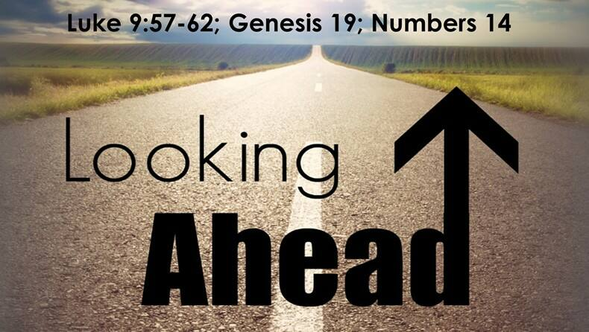

Like to plan events? Join us at the Fellowship and Social Ministries meeting on Wednesday February 1st at 7pm. We will be planning upcoming events for the next 6 months and would love your input and ideas!

Community To-Go Free Lunch and Clothing Giveaway is planned for Saturday February 18th, from 8am – 11am. More information to soon follow!

Spring Basket Raffle donations are due by Sunday March 18th, you may drop them off at the office or give them to Kim Marburger.

YOU are invited to gather for Coffee and Conversation on Sunday mornings at 8:45 AM in
Calvary’s Fellowship Hall. Everyone is welcome to attend this time of fellowship! If you wish to
provide a breakfast Danish, treat, fruit, or snack kindly sign up on the Fellowship Board (located on the ramp) for a specific date of your choice. Please see Becky or Marlene if you have any questions.

Aluminum Can Collection/Recycling at Calvary Please continue to bring your bagged aluminum cans to the lower double doors and place them in the cans with the blue lids. Thanks for your continued support.

Canning Jars are collected year-round, and saved for chow-chow and our annual Vegetable Soup Sale. You may leave your empty (pint and quart) jars, lids, and bands, at the lower double doors at any time. Thank you for recycling these items to help keep the cost of materials down!

Please remember to swipe your Save-A-Tape card when you check out at Redner’s Markets. The Save-A-Tape card MUST be used for your purchase to be credit to the church’s rebate total. Thanks again to everyone for turning in the tapes. Thank you to Marlene Latshaw for all the organizing and adding!

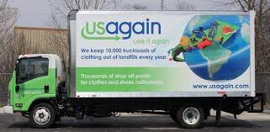
USAgain CLOTHING BINS at Calvary Thank you to all that help to fill our bins and help to reduce, reuse, and recycle clothing materials! Please keep in mind that once bags are dropped into the collection bins, the church has no access to them. So, if you are wanting to donate items to the Flea Market, or to Calvary’s Closet, please drop your items off at the lower doors. Thank you!

Calvary’s Closet News

Another busy time for us, as The Ann Frances Outreach Foundation was on the street every night that Code Blue was declared. For those of you not familiar with the term “Code Blue” this is put into effect any time that the outside temperature dips below 32 degrees. Code Blue puts the Street Outreach team into action, distributing hot meals, hot beverages, blankets, sleeping bags, sweatshirts, tents, pants, coats, hats, gloves and scarves to the unsheltered…many of which Calvary’s Closet has helped to provide thanks to your generous donations!
(…continued)
We have also been able to help several families in need with providing them clothes, shoes and pots & pans. Six people were assisted with clothing when they lost everything in a multi-unit house fire. A nine year-old child who lost her mother, was put into the custody of her grandfather, and we were able to provide her with winter clothing, shoes, a coat, and some small toys after we were notified that her grandfather really didn’t have anything for her.
These are just the newest updates to how we are helping those in need within our community, and putting donations to the best possible use! Thank you for your generosity in helping us, help those who need it the most.
Calvary’s Closet
If you or someone that you know could use a little helping hand with clothing or housewares,
please send an email to: CalvarysClosetBarto@gmail.com

Church News Box at Calvary
This little mailbox on a red pedestal holds copies of monthly newsletters, calendars of events, daily devotional books, and more! If you pick up your newsletter in person, you are invited to pick up your newsletters from this box if you are not able to pick it up while attending Worship.
This mailbox is open anyone!
The red pedestal mailbox is located at Calvary’s lower double doors.

______Notes from the administrator’s desk…_____

*The FEBRUARY & MARCH combined Newsletter Deadline is
Noon on WEDNESDAY February 8th*

*The APRIL Newsletter Deadline
is Noon on Monday
March 27th*

January Birthdays

1/7 Wesley Fox
1/9 Andrew Haring
1/10 Grant Fronheiser
1/14 George Jacob Jr.
1/15 Tyler Reigner
1/17 Levi Derstine
1/19 Joan Albitz
1/26 Virginia Angstadt & Noah Schwenk

*If you have a Birthday during the month and it was not mentioned, or the date is listed wrong, please let the office know. We are working to keep our records updated and your help in this effort is appreciated. Thank you.

- If you are going to the hospital, having surgery, or have recently been in the hospital, please inform Pastor Dave in one of three ways:
- Call him on his cell phone: 1-717-466-1216 - Email him: trumpet@dejazzd.com
- Call the Church office and leave a message

Mabel Schultz
Frederick Living
2849 Big Rd.
Third floor, room 1311
Zieglerville, PA 19492

Barbara Moser
Frederick Living
2849 Big Rd.
First floor, Apt 1102
Zieglerville, PA 19492
610-652-2263

Paul Schollenberger
P.O. Box 141
New Berlinville, PA 19545 610-367-9655

Thelma Borchelt
Frederick Living
2849 Big Rd. Apt. 1211
Zieglerville, PA 19492
610-652-5115

Janet Kulp
Amity Place Room #123
139 Old Swede Rd.
Douglassville, PA 19518
610-385-9745

Lillian Miller
3711 Hershey Ct.
Whitehall, PA 18052-3369
610-769-7318

Eileen Haring
1828 Big Rd.
Gilbertsville, PA 19525
610-754-6046

Sallie Fronheiser
241 Big Rd.
Bechtelsville, PA 19505
484-944-4504

