News from the pews
of
Calvary And PEnnsburg
United Church Of Christ
JUNE 2022
Pennsburg United Church of Christ
775 Main Street, Pennsburg PA 18073
phone # 215-679-7513
Church Office: pennsburgucc@gmail.com
Website: www.pennsburgucc.org
Join us on FaceBook! Pennsburg UCC

Jane Bernhard, Consistory President
Sharon Burns, Treasurer

Calvary United Church of Christ
1231 Route 100, Barto PA 19504
phone # 610-652-5023
Church Office: calvaryucc@gmail.com
Website: www.calvaryuccbarto.com
Join us on FaceBook! Calvary UCC Barto
Clothing Ministry: calvarysclosetbarto@gmail.com

Becky Crist, Consistory President
Linda Himeback, Treasurer
Dave Brumbaugh, Pastor
Heather Spaccarelli, Administrator

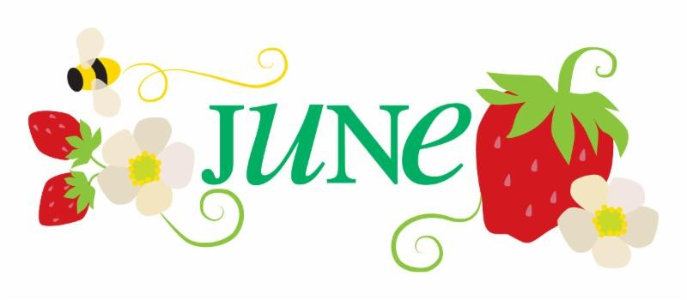

PASTOR'S MESSAGE

By this time, you may have received a letter from the consistories of Pennsburg and Calvary Churches. The letter was written to indicate that our shared ministry with the churches is coming to an end as of June 30, 2022.

It has been an honor and privilege to serve as your designated pastor during this time period. Shared ministry is a challenging option for churches these days. The reality is that some relationships thrive, some survive, and others go their separate ways. I, am a “move forward” type of person and pastor, and in doing so, I extend my thanks to the leadership and members of both churches for working with me as your designated pastor and for taking the risk to find avenues of common ministry coming out of the worst phase of Covid-19. We have worshipped together, exchanged ideas, debated how best to move forward for each church

and in the common shared ministry arrangement. I have appreciated the social times, mission opportunities, and many visits that have created unique times of "being" in the spirit, laughing, and talking about serious circumstances, all in the reality of prayers in residences, community homes, and retirement communities. Youth ministry was a joy at every meeting, and I am grateful that we had that outlet of ministry for young people.

While I look back and reflect upon our successes, which I believe were more than this current emotional separation probably allows at this time, I hope that the leaders and members of both churches will be able to express thanksgiving and gratitude for the time we have spent together. It is crucial, I believe, to see each "season" of serving the Lord as lessons that have been learned, with appreciation for one another, and with taking the best of what we have experienced into our future.

Following their decision to terminate the designated shared pastor arrangement with Pennsburg UCC, Calvary UCC has offered me an opportunity to be their designated pastor for a three-quarter time ministry beginning July 1, 2022. We are in the negotiating stages of such an arrangement with the assistance of the PA SE Conference, and no contract has been signed at this point. Having said that, the process needs to be followed according to the Faith and Order of the UCC and of the PA SE Conference. I am hopeful and confident that such an arrangement will come to fruition, and according to the letter written by the Calvary UCC Consistory, preliminary plans are in place for beginning my designated ministry at Calvary on July 1; again, contingent upon everything moving forward in a timely order.

In the Spirit of togetherness, common allegiance to Christ Jesus, and the work and presence of the Holy Spirit among us, I extend my equal prayers and hopes for both Pennsburg UCC and Calvary UCC in the common goals of building up the Kingdom of God the Father.

Blessings and Peace,
Pastor Dave

___________________________________

6/5 Calvary UCC, Consistory Meeting, Following Worship
6/27 Pennsburg UCC, Consistory Meeting, 6:30pm

2022 Calvary Consistory Officers
President – Becky Crist
Vice President – Rona Britton
Secretary – Sherry Bauer
Treasurer – Linda Himeback
Elders: Harold Albitz, Sherry Bauer,
Kim Marburger, Marlene Latshaw
Deacons: Rona Britton, Tracey Frey, Becky Crist, Sonya Spotts, Linda West
2022 Pennsburg Consistory Officers
President – Jane Bernhard
Vice President – Scott Mest
Secretary – Wendy Smedley
Treasurer – Sharon Burns
Team: Jane Bernhard, Jana Butler, Sharon Burns, Holly Lash, Scott Mest, Wendy Smedley, Adam Conrad

_______

Pastor Dave Brumbaugh - Worship begins at 9:30am...unless otherwise noted!
Join us in person or via Facebook Live or Zoom!

No computer or smart phone? No problem! You only need a phone to listen to Worship via Zoom!
Dial: 1-929-205-6099 and when prompted,
enter the Meeting ID 328 526 4749 and listen to the voice prompts for simple directions.

June 2022

(All worship services begin at 9:30 A.M. unless otherwise noted)

JUNE 05 - PENTECOST SUNDAY - at Calvary
Epistle Lesson: Acts 2:1-11
Gospel Lesson: John 14:8-17
HOLY COMMUNION
Message "The Spirit Arrives!"

JUNE 12 - TRINITY SUNDAY - at Pennsburg
Guest Accompanist: Ron Stabinsky
Epistle Lesson: Romans 5:1-5
Gospel Lesson: John 16:12-15
Message "Boasting - in a good way"

JUNE 19 -SECOND SUNDAY AFTER PENTECOST - at Calvary
FATHER'S DAY!
Epistle Lesson: Galatians 3:23-29
Gospel Lesson: Luke 8:26-39
Message "Breaking Free..."

JUNE 26 - THIRD SUNDAY AFTER PENTECOST - at Pennsburg
Guest Accompanist: Ernest Yeagley
Epistle Lesson: Galatians 5:1, 13-25
Gospel Lesson: Luke 9:51-62
Message "Freedom, But With A Cost"

*As a reminder, and with the increase in the Covid-19 variants, the consistory teams recommend the wearing of masks by everyone. If you have not received the vaccination for COVID-19 we strongly recommend wearing a mask.

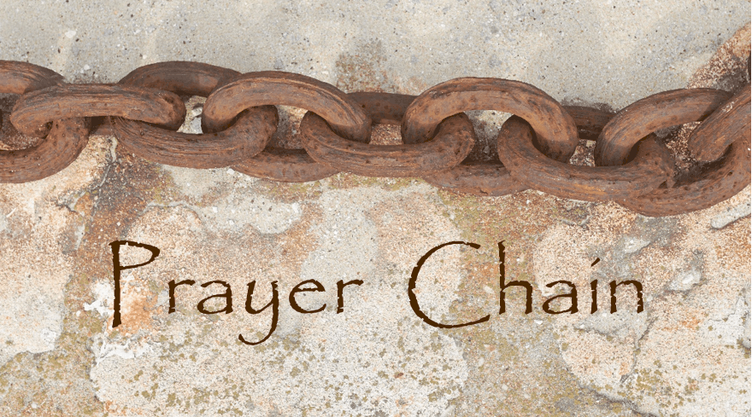
Prayer Chains are ready to pray for you!
If you need prayers for yourself or a loved one, reach out to Pastor Dave, or the church office and we will send the request through the Prayer Chain.

_________

The June “1st Monday Meal” will be held Monday June 6^{th,} from 6pm – 7pm at
Pennsburg UCC. It will be served drive-thru style by Lechneer & Stauffer. The menu is: Salad & Baked Ziti from Tosco’s and assorted baked goods for dessert.

25₵ Sale and a Pop-Up Yard Sale
Rain or Shine at Calvary UCC, Saturday June 18th from 8am-11am.
Outdoor vendor space is available for $10 per space.
Vendors do not need to register for this event, as plenty of outdoor space is available.
Vendor check-in and set-up will begin at 6:30am (kindly form a line of vendor vehicles at the basketball net)
The 25₵ Sale will take place in the upper-level Fellowship Hall, the Yard Sale will be in the grass area behind the basketball net, and the lower-level indoor Flea Market will be open for shoppers!
If you would like to volunteer to lend a helping hand the day of the event, please see Rona or Kim.
Additional questions may be directed to Heather in the office.
(Please share the attached flyer!)

10th Annual Make Music Upper Perk! You are invited to join the community music festival on Tuesday June 21st. This will be a magnificent and musical day in the Upper Perkiomen Valley, with over 300 people making music at 19 venues (on the lawn at Pennsburg UCC from 11am-5pm) in 4 different towns from 9 a.m. till 10 p.m. The longest day of the year will be full of fun and tunes and free entertainment, all organized and run by volunteers! There is something for everyone. Full details can be found at ValleyArtScene.wordpress.com or check the Town and Country newspaper on June 16th

SELL YOUR UNWANTED STUFF!!
Pennsburg UCC is hosting a Flea Market on Saturday, June 25th from 8:00 am to 1:00 pm. Space fee is by donation, and please bring your own table. There will be food, drinks, and homemade baked goods. Red Beets will also be for sale for $8.00 per quart. A portion of the proceeds will be donated to the Upper Perk Library. To reserve your spot please call Deb at 215-234-4158. Thank you, and see you on June 25th! (Please share the attached flyer!)

Free Community To-Go Meal, and Clothing Giveaway
will be held at Calvary UCC on Saturday June 25th from 8am-11am. This event will take place in Fellowship Hall on the upper level. Everyone is welcome to attend!!
(Please share the attached flyer!)

* Thank You to everyone that helps promote, volunteer, participates, and
gives their time to make events successful! *

Youth Group will meet on June 12th from 6:00 p.m. to 7:30 p.m. The youth group is open to children and youth in grades first thru twelfth. If you have any questions regarding the you group, please see Wendy Smedley, Holly Lash or Jana Butler.

CONGRATULATIONS GRADUATES!
Congratulations to Ryan Cleary, Cassie Mensch,
and Weston Mensch on your graduation from
Upper Perkiomen High School!
Your Friends and Family at Pennsburg UCC wish
you all the best in your future endeavors!

YOU are invited to gather for Coffee and Conversation on Sunday mornings at 8:45 AM in
Calvary’s Fellowship Hall. Everyone is welcome to attend this time of fellowship! If you wish to
provide a breakfast Danish, treat, fruit, or snack kindly sign up on the Fellowship Board (located on the ramp) for a specific date of your choice. Please see Becky Crist or Marlene if you have any questions.

The social ministries/fellowship commission will meet at Calvary on Wednesday, June 8 at 7:00 to discuss upcoming events. Everyone is welcome to attend and share their ideas!

Aluminum Can Collection/Recycling at Calvary Please continue to bring your bagged aluminum cans to the lower double doors and place them in the cans with the blue lids. Thanks for your continued support.

Please remember to swipe your Save-A-Tape card when you check out at Redner’s Markets.
The Save-A-Tape card MUST be used for your purchase to be credit to the church’s rebate total.
Thanks again to everyone for turning in the tapes.
Thank you to Kathy Badman at PUCC, and Marlene Latshaw at CUCC, for all the adding!

Calvary’s Closet…
If you or someone that you know could use a little helping hand with clothing or housewares,
please send an email to: CalvarysClosetBarto@gmail.com

USAgain CLOTHING BINS at Calvary Thank you to all that help to fill our bins and help to reduce, reuse, and recycle clothing materials! Please keep in mind that once bags are dropped into the collection bins, the church has no access to them. So, if you are wanting to donate items to the Flea Market, or to Calvary’s Closet, please drop your items off at the lower doors. Thank you!

Church News Box at Calvary
This little mailbox on a red pedestal holds copies of monthly newsletters, calendars of events, daily devotional books, and more! If you pick up your newsletter in person, you are invited to pick up your newsletters from this box if you are not able to pick it up while attending Worship.
This mailbox is open anyone!
The red pedestal mailbox is located at Calvary’s lower double doors.

Online Giving/Electronic Giving Update, CUCC… As some of you may have noticed, our online giving company, Vanco, has been experiencing some technical difficulties that were not allowing transactions to be completed. For this reason, we have cancelled our services with them and are currently looking for another e-giving service to take its place. Please watch for an announcement once we have reached an agreement with another source. In the meantime, you are always welcome to bring your offering on a Sunday morning, or mail it to the church office. Thank you for your understanding with technical difficulties!

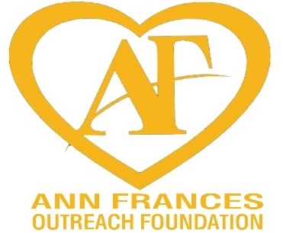
The Ann Frances Outreach Foundation is currently in need of NEW adult sized socks and underwear. The foundation will distribute these undergarments to homeless people whom they are currently helping to improve their situations. If you are able to donate to this cause, you may leave your donations at Calvary’s lower double doors, with a note attached stating “AFOF” this way our volunteers will be able to quickly place them in the hands of the Ann Frances Outreach Foundation to make a difference in someone’s daily life! Other items that are much appreciated are gently used or new casual t-shirts, and elastic waist pull-on style shorts, all in all adult sizes.
Thank you for your support!
The Outreach Ministry at Calvary is in the early stages of planning a
Back-to-School Community Outreach Event!
We know what you’re thinking, “Back to School already?!” …It will be here before we know it, so we are getting a head start!
We have begun to collect school supply items, and will continue to collect through August 7th. Items that we are collecting include: Pencils, Erasers, Backpacks, Single Subject Notebooks, Folders, and more. These items will stay within the community, helping students to have a successful upcoming school year. More information to follow in the near future, stay tuned!
A box has been placed in the Narthex to place any school supplies in that you wish to donate. If you would prefer to donate monetarily, or if you have any additional questions, please speak with Rona.
Thank you for your continued support!

______Notes from the administrator’s desk…______

Just an FYI:
Heather will be out of the office (with limited access to email and calls) on June 7th & 8th, 10th - 13th.

*The JULY Newsletter Deadline
is Noon on WEDNESDAY
JUNE 22nd*

A special “Thank You” to Linda West, for giving her time to sparkle up the Narthex & Greeting area at Calvary by cleaning all of the windows - inside and outside!
Next time you take a moment to stop and chat upstairs, take notice of how much
brighter it is! Thank you, Linda!

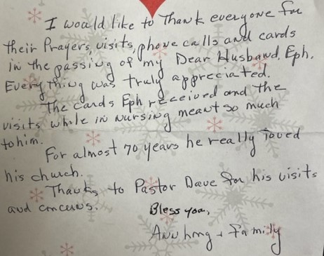

Thank You from Audrey:

“I want to thank the members and friends of Pennsburg United Church of Christ for the very nice good-bye on my last Sunday as organist at Pennsburg U.C.C. The gift, cards, and well-wishes were appreciated very much. I miss all of you, especially the members of Pennsburg’s choir, past and present.

Also thank you to Calvary U.C.C. for the beautiful flower arrangement on my last Sunday that I played the organ for worship. I enjoyed meeting you while I was substituting at the organ for worship. Thank you to Pastor Dave for his support in the short time that we worked together.

May God add his blessings to the shared ministry of Pennsburg U.C.C. and Calvary U.C.C.”

Peace,
Audrey Reinhart

June Birthdays

6/1 Heather Reigner & Kira Reigner
6/4 Donald Nuss, Thomas Kunkle, Anna Long, Paula Sell
6/5 Floyd Cressman
6/8 Brayden Breyer
6/11 Eric Keebler
6/12 Katelyn Oister
6/13 Amy Shafer, Jo Ann Longacre
6/14 Donna Himmelberger
6/15 Raymond Koffroth
6/16 Lori Hawkins, DeeDee Smith
6/17 Melissa Koons
6/18 Ryan Ruth. Shirley Neiman
6/24 Alyssa Crist, Gerald Brey, Bill Kurz
6/26 Jace Stofflet, Jaxon Huff
6/27 Sharon Haas, Eileen Koffroth
6/29 Barbara Nuss, Drew Haring

*If you have a Birthday during the month and it was not mentioned, or the date is listed wrong, please let the office know. We are working to keep our records updated and your help in this effort is appreciated. Thank you.

June Anniversaries

6/2 David & Jennifer Bickley & Dean & Marlene Latshaw 6/3 Grant & Sallie Fronheiser
6/14 Rev. Daniel & Peggy Moser 6/17 Anthony & Barbara Parestis
6/27 Fred & Donna Kroncke 6/30 Robert & Patricia Burns
*If you have an Anniversary during the month and it was not mentioned, or the date is listed wrong, please let the office know. We are working to update our records and your help in this effort is appreciated. Thank you.

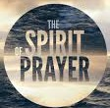
- If you are going to the hospital, having surgery, or have recently been in the hospital, please inform Pastor Dave in one of three ways:
- Call him on his cell phone: 717-466-1216
- Email him: trumpet@dejazzd.com
- Call the Church office and leave a message
Carol Huff
315 Bassett Ct.
Limerick, PA 19468
484-932-8629

Mabel Schultz
Frederick Living
2849 Big Rd.
Apt. 2124B
Zieglerville, PA 19492

June Brinckman
The Village of LifeQuest
2100 Cherry Blossom Lane
Quakertown, PA 18951
215-679-7015

Grace Grubb
Pennsburg Manor
Room #214A
530 Macoby St.
Pennsburg, PA 18073
215-679-5030

Howard & Barbara Moser
Frederick Living
2849 Big Rd.
Apt. 116
Zieglerville, PA 19492

Paul Schollenberger
P.O. Box 141
New Berlinville, PA 19545-0141

Bobby Smith
1491 Markley Rd.
Pennsburg, PA 18073
215-679-9350

Lydia Maurer
502 Main St. Apt. A
East Greenville, PA 18041
215-679-7093

Thelma Borchelt
Frederick Living
2849 Big Rd. Apt. 1211
Zieglerville, PA 19492
610-652-5115

Shirley Pursel
134 Concord Dr.
PO Box 155
Hereford, PA 18056-0155
215-679-5644

Janet Kulp
Amity Place #123
139 Old Swede Rd.
Douglassville, PA 19518

Randy & Beverly Reinert
809 Holly Dr.
Green Lane, PA 18054-2022
215-234-8208

Peggy Schwenk
Parkhouse Nursing & Rehab Center
1600 Black Rock Rd.
Room #224
Royersford, PA 19468

Lillian Miller
3711 Hershey Ct.
Whitehall, PA 18052-3369

Emily Hoff
420 Macoby St.
Pennsburg, PA 18073

Betty Althouse
159 Main St.
Pennsburg, PA 18073
215-679-8179

Eileen Haring
1828 Big Rd.
Gilbertsville, PA 19525

Calvary’s Corner
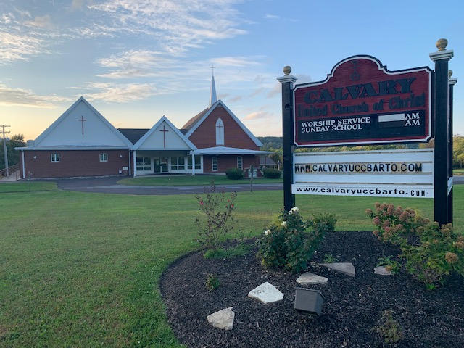

Be A Good EGG (Electric and Gas Giver)
Update From Stewardship and Evangelism

THANK YOU!!! THANK YOU!!!

Our “be a good EGG” campaign continues, and we are almost half way to the goal!

As of 5/25/2022 we have collected $1,415 for the campaign.

Thank you for all who have donated so far, all monies collected are being
designated to help cover the additional cost for Electric and Gas.

We appreciate all you do!

Blessings,
Sherry Bauer & Becky Crist
A Note from Consistory…
June is here, the month that Summer officially begins and the temperatures heat up. As we look forward to vacation time, getaways, and summer fun, we wish to remind you that our church services continue to be available for viewing on Facebook and Zoom.
Over the past couple years Covid sure changed things up. We can’t thank you enough for your continued support, help, and giving that have helped keep Calvary alive and our ministries growing. Things might have changed, but we have survived and continued to grow stronger. However, there are faces that we miss seeing. Calvary cares about you and wish to welcome you back! Some of our members still mask, we can still socially distance within the pews, our communion is still single serving size picked up upon entering the sanctuary and our offerings are dropped in the offering box. You can worship in whatever way makes you comfortable. We want you to know we miss your friendly faces and hope to catch up with you and see you in the pews one Sunday soon. (Please let us know if there is something concerning you about in person service.)
Exciting things are happening at Calvary. We have resumed our fellowship time before services. Join us at 8:45 on Calvary’s Sundays for Coffee and Conversation. Enjoy some treats, catching up with friends and meeting new friends. A sign-up sheet hangs on the ramp bulletin board if you would like to provide refreshments. We are also bringing back the blood pressure checks. Watch for dates on when checks will be done.
Our Outreach and Fellowship group is planning a Free Community Event on August 20th, 2022. They will be meeting soon and finalizing some planning, but we already have Threefold Blessing, The Ann Frances Outreach Foundation, Miller Keystone, and the Keystone Ghostbusters Group on board. This totally free event will include clothing and back to school giveaways, free food, entertainment and more. Boxes are in the Narthex to collect school supplies (backpacks, notebooks, crayons, pencils, folders, etc.).
We also continue to support The Humane Society with much needed bedding, The Ann Frances Outreach Foundation, and Purple Heart with clothing and household supplies. We are still collecting individual snack items (granola bars, raisins, snacks, etc.) to help the Ann Frances street ministry to the homeless. Our outreach ministry is strong and our presence in our community is stronger. Calvary UCC has become well known in our community - and the surrounding communities for the help we give. We feel so blessed to be able to help so many. Thank you to everyone who makes this possible.
June is also the month of Graduations! Congratulations to all the 2022 Grads! Please contact the church office if you are a member graduating this year.
Online giving and electronic giving options are still being looked into. We hope to have these options available soon.
Join us June 5th as we celebrate Pentecost and decorate our sanctuary with geraniums. On June 19th we honor all men who are fathers and father figures with a sweet treat.
Thank you to all our “Be A Good EGG” givers. We are almost half way to our $3,000.00 goal to help ease the increased utility expenses. YOU ARE AWESOME!
If you joined us for worship on May 22nd, I think you will agree that Threefold Blessing sounded great with our new microphones! Thank you, Kim, for all your research and meetings with the audio guys to make sure we can enjoy beautiful services. Kim Marburger and Fred Kroncke are still working on getting our downstairs LED light transition completed. Conrad Electric will be out to complete a couple lights, leaving just the center row in the social hall that is pending the availability of covers.
Do you have an idea to share? A program you wish to see at Calvary? Maybe a gathering group that you would like to see return? An opportunity to explore? Please join us at our next consistory meeting, contact the church office, or any consistory member to share your thoughts and ideas.

“The church is not a building, the church is not a steeple, the church is not a resting place,
The Church is the People. I am the church, You are the church, We are the church together. All who
follow Jesus, all around the world, Yes, We’re The Church Together!”

May God’s Peace and Presence be with you every day,
Becky, Rona, Kim, Sherry, Marlene, Harold, Sonya, Linda and Tracey

