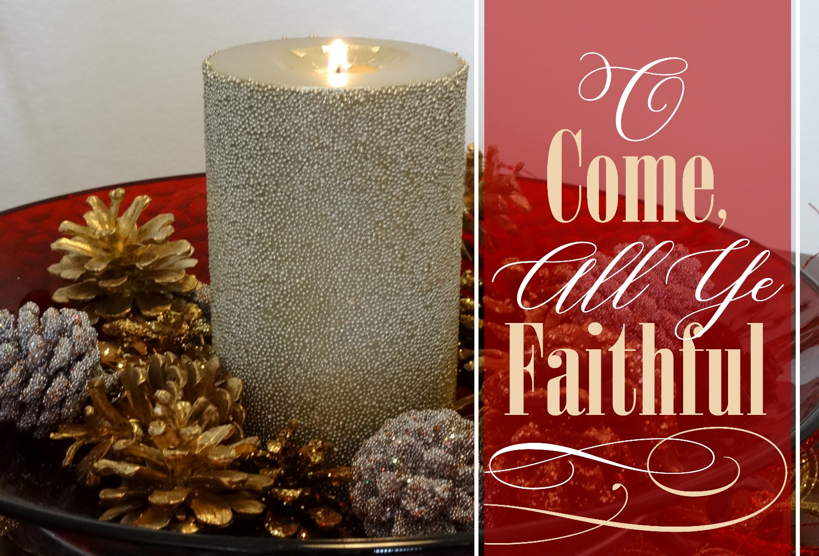

Pennsburg United Church of Christ

775 Main Street, Pennsburg, PA 18073, 215-679-7513

www.pennsburgucc.org pennsburgucc@gmail.com

Rev. Meagan McLeod, Worship Leader

Mrs. Audrey Reinhart, Director of Music

December 27th, 2020

PRELUDE: “It Came Upon the Midnight Clear” arr. Matthews

WELCOME & ANNOUNCEMENTS

CALL TO WORSHIP

One: In the beginning, there was the Word;

Many: the Word was in God’s presence, and the Word was God.

One:The Word was present to God from the beginning.
Through the Word all things came into being… .

P:In the Word was life, and that life was humanity’s light- –

L:And the Word became flesh and stayed for a little while among us;

All Together: we saw the Word’s glory—
filled with grace, filled with truth.

Let us rejoice in the Word!

OPENING HYMN “O Come, All Ye Faithful”
“O come, all ye faithful, joyful and triumphant,
O come ye, O come ye to Bethlehem; come and behold him,
born the King of Angels;
O Come, let us adore him, O come, let us adore him,
O come, let us adore him, Christ, the Lord.

(The congregation may be seated.)

LIGHTING THE ADVENT WREATH - The Christ Candle
All: God of highest glory, all our days belong to you. You alone are worthy of our praise, devotion, and thanksgiving. We, who already have so much, dare to ask for one more thing. We humbly ask that you fill our hearts with Christmas grace—the power to restore, to welcome, to celebrate, and to see Christ’s power brought forth in this world. Pour this grace into our hearts, and give it substance in our thoughts, our words, and our deeds. In Christ’s name, we pray. Amen.

CALL TO CONFESSION
Christ comes to us, though stained by sin we are hardly worthy of standing in his presence. So, let us come before him, humbly confessing so that we might be forgiven…

UNISON PRAYER OF CONFESSION
Prayer of Confession

When we close ourselves off from the Light of the World
Struggling to illuminate the lives of everyone, especially those who are poor and oppressed:

Lord, have mercy.

When we close ourselves off from the Wisdom of God,
Struggling to be heard above hate-filled words and fear-filled rhetoric:

Christ, have mercy.

When we close our hearts off from the Glory of God,
Which is known fully only in a world of peace where all creation thrives,

Lord, have mercy.

DECLARATION OF FORGIVENESS
In Christ, the Light, the Word, the Glory of God’s love
shines in our hearts, and we are forgiven and given strength to
go forward into a new future. Let us give thanks that in Jesus,
Emmanuel, God is truly with us.

PRAYER OF ILLUMINATION

All: God, where there is darkness, may your Word shed light. Where there is emptiness, may your Word bring fullness. Where we are closed, may your Word make us open. Where there is sorrow, may your Word make us hopeful and glad. Amen.

SCRIPTURE READING
Jeremiah 29:11
Luke 2:1-8
Song: “The First Noel”

SERMON: Pastor Meagan

COMMUNION
Pennsburg UCC invites to an open Table all who wish to encounter Jesus in the broken bread and poured-out cup.

Invitation to Communion of Epiphany
(written by Rev. Michelle L. Torigian)
One: Here at this table and in this sanctuary, let the Divine Spark enter our lives.
Many: Let the Holy Light aid us in seeing the Christ in our midst.
One: The Brightness of Jesus the Christ will illuminate our way.
Many: The Radiance of the Christ will warm our hearts.
One: God is shining upon you!
Many: And God’s light streams upon you!
One: Open your hearts.
Many: We open them to the brilliance of God.
One: Let us give thanks for the light and love of God.
Many: We praise our Creator with joy and thanksgiving

Prayer

One: We enter this stunning space eager to experience the presence of the Christ. Notice the Christ in the cries of the children. Spot the Christ your neighbor’s singing. Recognize the Christ in the laughter from the back of the sanctuary. The Christ is gleaming here, summoning us to share love and light as we greet our neighbors, share peace, pass the bread and cup, and love kindness across this earth.

On the night before Jesus died, when some were plotting to extinguish the Holy Light, warmth was shared between friends. Jesus took bread. In his blessing, he passed the Divine Glow to his followers. As he broke the bread, he reminded them to eat in remembrance of him.

Later that same evening, Jesus took the cup. He blessed it and invited his friends to taste from the cup of grace. “Do this, as often as you drink of this, for the remembrance of me.”’

Holy Spirit, may your Divine Glow bless this bread and cup. Warm our hearts made cold by a chilled world. May this meal inspire us to carry your warmth into our world. Amen.

Distribution of the Elements

Unison Prayer of Thanksgiving
All: God of Light and Love, we cherish this table in this season when the nights are long and cold. Through this meal, the Christ, and our neighbors, our hearts have warmed. May the comfort in our souls sustain us through winter and nudge us to create welcoming spaces for our neighbors. With gratitude, we leave here energized to kindle your love in this world. Amen.

SHARING OF JOYS AND CONCERNS

PRAYERS OF THE PEOPLE

THE LORD’S PRAYER
Our Father, who art in heaven, hallowed be thy name.
Thy Kingdom come, Thy will be done, on earth as it is in heaven. Give us this day our daily bread. And forgive us our debts as we forgive our debtors. And lead us not into temptation, but deliver us from evil. For Thine is the Kingdom and the power and the glory, forever. Amen

OFFERING INVITATION

(All who are able please rise)

OFFERING RESPONSE: “In the Bleak Midwinter”
What can I give him, poor as I am?
If I were a shepherd, I would bring a lamb;
If I were a wise man, I would do my part;
Yet what I can give him: give my heart.

OFFERTORY PRAYER

SHARING THE LIGHT

P: Christ is the True Light come into the world. He is a light that the darkness cannot overcome. As we share light from the Christ candle with each other, it is a reminder that we carry the light of Christ with and in us and that as we share that light of hope, peace, joy, and love, the darkness of sin and evil continue to be defeated.

HYMN “Silent Night"
Silent night!, Holy night! All is calm, all is bright, round yon virgin mother
and child, holy infant, so tender and mild, sleep in heavenly peace, sleep
in heavenly peace.

BENEDICTION

CLOSING HYMN “Joy to the World!"

“Joy to the world! The Lord is come, let earth receive her King; Let every heart prepare him room, and heaven and nature sing, and heaven and nature sing, and heaven and heaven and nature sing.

SILENT MEDITATION

POSTLUDE “Postlude on A Christmas Carol” arr.Wilson/Peery

