News from the pews
of
Calvary And PEnnsburg
United Church Of Christ
“Together for the Greater Good!”
NOVEMBER 2021
Calvary United Church of Christ
1231 Route 100, Barto PA 19504
phone # 610-652-5023
Church Office: calvaryucc@gmail.com
Website: www.calvaryuccbarto.com
Join us on FaceBook! Calvary UCC Barto
Clothing Ministry: calvarysclosetbarto@gmail.com

Linda Himeback, Treasurer

Dave Brumbaugh, Pastor
Heather Spaccarelli, Administrator

Pennsburg United Church of Christ
775 Main Street, Pennsburg PA 18073
phone # 215-679-7513
Church Office: pennsburgucc@gmail.com
Website: www.pennsburgucc.org
Join us on FaceBook! Pennsburg UCC

Sharon Burns, Treasurer

PASTOR'S REFLECTIONS

"We are the Lord's people, the sheep of the Lord's pasture;
enter the Lord's gates with Thanksgiving;
enter into the Lord's gates with Praise." - Psalm 100

Thanksgiving - the often forgot about holiday (holy-day), except for the baking of turkeys, hams, potatoes, pie, etc. Halloween now annually garners $10 Billion in commercial spending by American Consumers. Christmas - at least the commercial end of Christmas - even more. Costumes, decorations, food, travel, vacations. How and where does God fit into all of that? We can't be too critical of those who are unchurched or who don't have a relationship with God as we do in the Church, because, well, they don't - have a relationship with God.
That's not judgmental - it's just what it is.

But we, the Church, do have a responsibility to God, and to be thankful, praising, and joyful. That is not only a choice, but it is an expectation that God laid at the foot of God's people in both the Old and New Testaments. There are many Psalms with thanksgiving and praise - and not just when things are going well.
The Psalmist is candid about hard times, difficult decisions to be made, and even
persecutions for being God's people. The Gospels and Epistles have their verses of "Thanksgiving Encouragement", too.

We cannot and should not, in my opinion, relegate Thanksgiving to just
a national holiday, although it has some significance in that regard.
And we should not condition our thanks only upon how we are feeling at the moment, or if life is good verses bad. Our thanksgiving to God and for God
is not conditional, except upon the fact of Christ's crucifixion and resurrection, and how those events have eternally shaped our lives in this world and for the next (heaven and salvation). Our thanksgiving to God needs to be consistent, regardless of our situation in this life. Because, "for this life only", is not the only life we share or will share with God.

Even through disappointment, hurt, anger, depression, and other sorrows....
can we not muster enough faith to give God thanks? I believe we can.
I believe we should. There is a long track record of faithful people who have gone before us who have done just that. Thanked God daily for not only the blessings of life, but the challenges in life that test our faith, but which can also strengthen our faith and faithfulness.

Be thankful, yes, and hopefully share some time in person, on the phone,
virtually - however - with family and or friends. But remember that God is at the center of even those occasions and events. We have been invited by God to join the Kingdom, and we are part of the Kingdom through grace, mercy, faith, and love. Now that's something to be thankful about all the time - not just on one day of one month out of the year!

Blessed Thanksgiving!
Pastor Dave

~~~~~~~~~~~~~

A MESSAGE FROM BRENDA FIDLER, PASTOR DAVE'S WIFE

I would like to wish everyone a blessed Thanksgiving. Both David and I are grateful for your welcome to the Pennsburg and Calvary Churches. We appreciate your support and patience as we moved from Tallmadge, Ohio to PA, which was way more involved than we anticipated. We began looking for a home in March and lost out on a few because of other's over-bidding way beyond the asking and appraised value of the homes (some were in the range of $50,000
over-bidding!). We made a bid on a home in Fleetwood in May and the offer was accepted by the owners. The owners requested a couple months to get things ready for their move, which we agreed to, prior to deciding upon a settlement date. However, at the end of the two months, the sellers decided not to sell and took the home off of the market. At that point we decided to rent an apartment in Royersford, finding that no apartment rentals closer to
the churches were available. However, that apartment wasn't available until the middle of September. So, during the waiting process, David and I continued to remain open to the sale of houses in a radius of a maximum of 30 miles from both churches. While we concentrated our search in the hopes of finding a home in Western Montgomery County or Eastern Berks County, the more affordable offerings were closer to Reading. Fortunately, a home in the Exeter - Mt. Penn Area, east of Reading became available and we moved in October 7. It already feels like home, and we are thrilled to be back in the greater Eastern Berks Western Montgomery area. We also have a buyer for our home in Tallmadge, Ohio, and are waiting on a settlement date.

I am also continuing to work for the company I have worked for over the past two years, which is done remotely, and requires some work on evenings, weekends and holidays. This company serves mostly senior adults who have mental and psychiatric challenges and who need to be hospitalized in a Geriatric Psychiatric facility. Please continue your prayers for David and I, as we continue our prayers for Calvary UCC and Pennsburg UCC, and as we work together to represent the Lord and to embrace the tasks before us with happy hearts in the service of others and a vision for the future of the Church.

Blessings, Brenda Fidler

___________________________________

11/15 Pennsburg UCC, Consistory Meeting, 6:30pm
11/21 Calvary UCC, Consistory Meeting, Following Worship

2021 Calvary Consistory Officers
President – Harold Albitz
Vice President – Rona Britton
Secretary – Sherry Bauer
Treasurer – Linda Himeback
Elders: Harold Albitz, Sherry Bauer,
Kim Marburger, Marlene Latshaw
Deacons: Rona Britton, Tracey Frey, Becky Crist, Sonya Spotts
2021 Pennsburg Consistory Officers
President – Jane Bernhard
Vice President – Dana Heimbach
Secretary – Paula Sell
Treasurer – Sharon Burns
Team: Jane Bernhard, Jana Butler, Sharon Burns, Danielle Felix, Dana Heimbach, Bill Kurtz, Holly Lash, Scott Mest, Gail Schmoyer,
Paula Sell, Wendy Smedley

_____________

Pastor Dave Brumbaugh - Worship begins at 9:30am.
Join us in person or via Facebook Live or Zoom!

No computer or smart phone? No problem! You only need a phone to listen to Worship via Zoom!
Dial: 1-929-205-6099 and when prompted,
enter the Meeting ID 328 526 4749 and listen to the voice prompts for simple directions.

NOVEMBER 07 - ALL SAINTS CELEBRATION AT CALVARY
Remember the Saints of Calvary UCC
Epistle Lesson: Revelation 21:1-6
Gospel Lesson: Mark 12:38-44
Message "The New Jerusalem"

NOVEMBER 14 - PENNSBURG UCC
Veterans Recognition Sunday
(Veterans of the five branches of service to the U.S. will be invited to come forward and be recognized)
Baptism of Mary Conrad
Gospel Lesson: Mark 13:1-8
Message "Loyalty and Sacrifice"

UCC PA Southeast Conference Annual Meeting - Zoom

NOVEMBER 21 - CALVARY UCC - THANKSGIVING SUNDAY
Gospel Lesson: Matthew 11:16-19
Message "What We Can't Take for Granted"

Pennsburg UCC Annual Congregational Meeting - 11:30 A.M.
@ PUCC (lunch + meeting)

NOVEMBER 24 - COMMUNITY THANKSGIVING EVE WORSHIP
Place: Most Blessed Sacrament Church (Catholic Church)
610 Pine St. Bally, PA 19503
Time: 7:00 P.M. (Fellowship time afterward)
Pastor Dave will participate in this service
(The Upper Perkiomen Ministerium decided not to host a Thanksgiving Eve service this year)

NOVEMBER 28 - PENNSBURG UCC - FIRST SUNDAY OF ADVENT
Lighting the First Advent Candle
Gospel Lesson: Matthew 24:36-44
Message: "Watching for the Unexpected Hour"
*As a reminder, and with the increase in the Delta variant, the consistory teams recommend the wearing of masks by everyone. If you have not received the vaccination for COVID-19 we strongly recommend wearing a mask.

ZOOM UPDATE!
Members of PUCC will continue to ZOOM Sunday morning worship services. Please note, we are trying our best to provide a clear picture and audio of the service. The Zoom media is not designed to for large area meetings. Zoom picks up the closest sound, and transmits that sound. Unfortunately, music does not “sound” or transmit very well over Zoom. Thanks for understanding. - PUCC Worship Committee

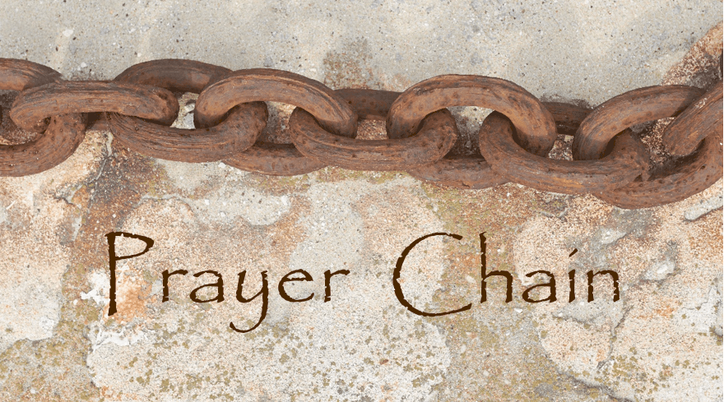
Prayer Chains are ready to pray for you!
If you need prayers for yourself or a loved one, reach out to Pastor Dave, or the church office and we will send the request through the Prayer Chain.

________________

The November “First Monday Meal” will be held on Monday November 1st, from 6:00 p.m. to 7:00 p.m. at Pennsburg U.C.C. It will be served drive-thru style by Upper Perk Lion’s Club. The menu is: Sausage Sandwich with peppers, onions & sauce OR 2 hotdogs. Also included are a bag of chips, drink and dessert.

Calvary’s Christian Social Ministries and Fellowship Commissions will meet on Monday, November 8 at 7:00 PM. All are welcome to attend this meeting to plan for 2022 events. Come join us, and bring your ideas!

Cookie baking time is upon us!
We will bake cookies (& pies!) again this year, which will be for sale at Calvary’s
Annual Bazaar, Bake Sale, Basket Raffle & Flea Market!

Dough Mixing – Tuesday, November 9 – 4:30 – 5:30 PM
Roll and bake cookies – Thursday, November 11 – 4:30 – 8:30 PM
Roll and bake cookies – Saturday, November 13 – 7:00 AM – 2:00 PM

Pie baking will take place on Friday, November 19 – 7:00 AM – 2:00 PM

All are welcome to help bake the cookies and pies that will be sold at the annual bazaar, bake sale,
basket raffle and flea market on Saturday, November 20 from 9:00 AM – 1:00 PM.

*We will also be accepting donations of baked goods to sell at the annual bazaar.

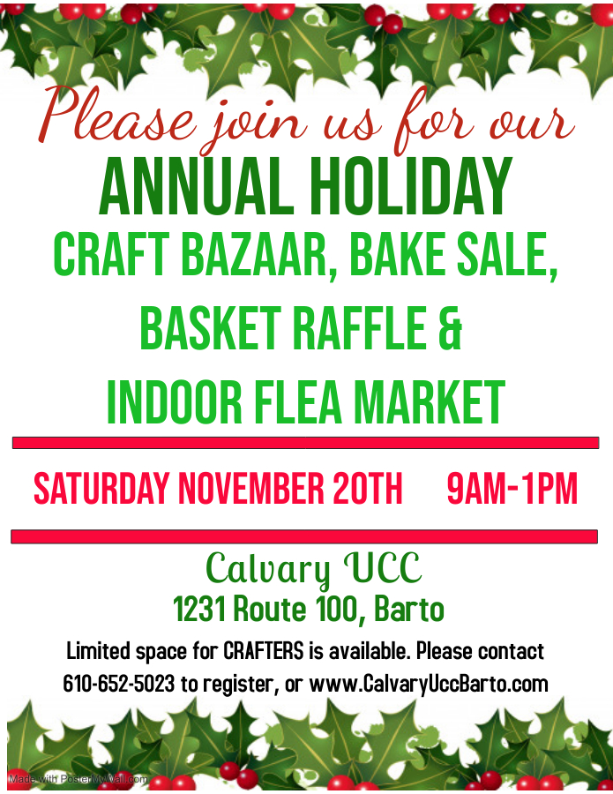

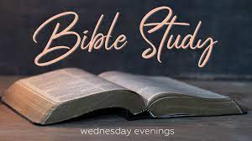

Bible Study And Discussion Group With Pastor Dave

November 11 @Pennsburg UCC
Topic: The Depth of Spiritual Thanksgiving

November 18 @Calvary UCC
Topic: Christmas is________ (exploring the connection between Christmas, Good Friday, and Easter)

TIME: 6:30 P.M. – 7:30 P.M.

WHAT: Bible study, discussion time, drinks and lite snacks

(We will endeavor to connect virtually with those who might like to “check in” via Zoom).
If you are interested in connecting virtually, please leave your name and phone number on one of the answering machines at Pennsburg UCC (215-679-7513) or Calvary UCC (610-652-5023). The deadline for signing up for the virtual connection is Sunday, November 14.

* Thank You to everyone that helps promote, volunteer, participates, and gives their time to make events successful! *

________________

Free Community To-Go Meal & Coat Giveaway! Saturday December 4th, Noon – 1pm! Event will be held at Calvary UCC, in the Fellowship Hall. A flyer is attached to this newsletter, and additional ones are available in the greeting area. If you have any questions please contact the Church Office, 610-652-5023.
A sign-up sheet has been posted on the Fellowship Board for Volunteers!
Let’s work together to make this another successful event serving our community!

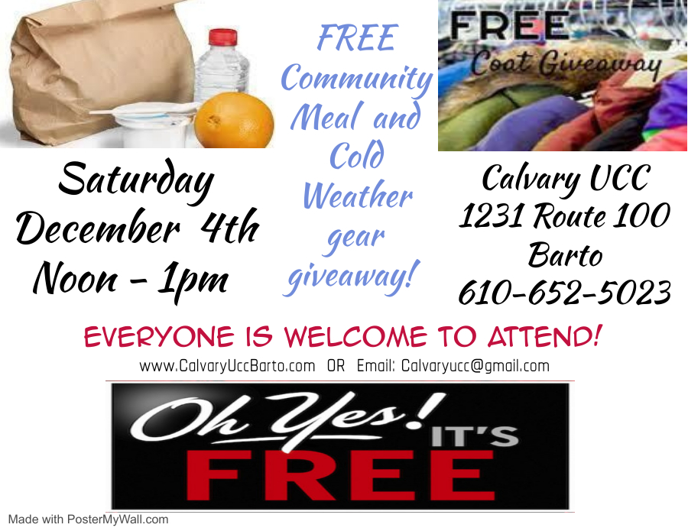

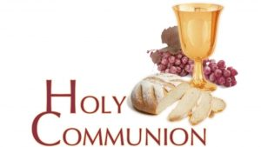

Advent Service of Holy Communion Sunday, December 5, beginning at 9:30 AM, At Calvary, featuring a Mission Moment with The Ann Frances Outreach Foundation.

Following Worship will be the annual Congregational Meeting.

Toy Drive as the Holiday Season is approaching, Calvary is once again partnering with the Ann Frances Outreach Foundation to help collect Toys! This partnership allows them to help families in the Pottstown area. Help us, help them, help kids to have a brighter holiday season!
New, unwrapped, toys are currently being collected for children ages birth-16 years old. Donations may be left in the box in our greeting area between now and Friday December 3rd.
This year the Christmas Wish of the Ann Frances Outreach Foundation is 2,500 toys for over 150 families!
Thank you for your kindness this Holiday season! If you have any questions, please contact Heather in the church office. Thank you!!!
Some ideas of toys that the children really enjoy are:
Trucks, Remote control cars, Hot wheel cars (5 pack), Basketballs, Legos, V-tech learning systems,
Paw patrol, Footballs, Soccer balls, Actions figures, Black baby dolls, Black Barbie dolls,
Baby strollers, Crafts, Barbie horses, Blues clues, Scooters
If you would prefer. you can also give a donation at www.AnnFrances.org
Thank you for your love, support, and generosity

ATTENTION ALL VETERANS!!!.....

We are inviting all Pennsburg UCC and Calvary UCC Veterans to attend the worship service at Pennsburg UCC on Sunday, November 14, beginning at 9:30 A.M. At this service, we will invite our Veterans (Any combat or non-combat service) who have served in the U.S. Army, Navy, Air Force, Marines, or Coast Guard to come forward to receive a lapel pin in appreciation for your service. It is also important to call the Church offices and give us your name, branch of service, and years of service so that we can recognize you in the bulletin.

Don't forget! Sunday School will be held on Sunday's that worship is held at Pennsburg.
Sunday School is available for children ages 2, thru 5th Grade.

CHILDREN AND YOUTH ADVENT – CHRISTMAS MINI-DRAMA
Pastor Dave is writing a mini-drama for Pennsburg and Calvary youth. The drama will be shared with the congregations at Pennsburg UCC on the Second Sunday of Advent, December 12. ALL CHILDREN AND YOUTH are invited to participate. There are both speaking and
non-speaking parts. The drama will be discussed at the November 14 children and youth meeting at Pennsburg Church from 6:00 – 7:30 P.M.
The title of the mini-drama is: “BRINGING A GIFT…TAKING A GIFT”
If your child or you, as a youth, are interested in participating, please
Contact Holly Lash or Wendy Smedley of the Pennsburg Christian Education Committee, who is coordinating this opportunity.

Calendar Collection
Are you starting to get 2022 Calendars in your mailbox and already have enough for every room in your home? Bring the extras to PUCC! A former minister at New Goshenhoppen will take them to prisons for the inmates. Only calendars held together with staples are accepted. Look for the calendar box at PUCC!

Pennsburg UCC Consistory and Committee Members Needed!
Looking for a way to be more involved with the church? Pennsburg UCC is looking for 3 more
of our members to be part of consistory for 2022. Meetings are held monthly. A term is 2 years
with the option of continuing into a second term.
If interested, please contact Jane Bernhard, President, or any other current member of consistory.

In addition, there are multiple committees to take part in at Pennsburg UCC:

Caring and Sharing, Cemetery, Christian Education, Fellowship, First Monday Meal,
Investment, Outreach & Growth, Property, Stewardship, Worship

If you are interested in joining or hearing more about any of these committees please reach
out to any member of consistory.

LOCAL AND WIDER CHURCH MEETINGS AND OPPORTUNITIES:
- Calvary UCC and Pennsburg UCC Joint Consistory Meeting – Nov. 3, 6:30 P.M. @Calvary
- Pennsylvania Southeast Conference Annual Meeting – Nov. 14, 2:00 P.M.
- Pennsburg UCC Consistory – Nov. 15, 6:30 P.M.
- Pennsburg UCC Annual Congregation Meeting – Nov. 21, 11:30 A.M.
- Calvary UCC Consistory – Nov. 21, 10:45ish A.M.
- Community Thanksgiving Service @Most Blessed Sacrament, Bally – Nov. 24, 7:00 P.M.
- Calvary UCC Annual Congregation Meeting – Dec. 5, 10:45ish A.M.

PUCC ADVENT DEVOTIONALS FOR ADULTS, CHILDREN, AND YOUTH
Advent Devotionals and other learning and celebrating materials for the Advent and Christmas seasons will be available sometime close to the Advent Season. Advent begins November 28.

Christmas Poinsettia Order Information

Pennsburg UCC
It’s Beginning to Look Like………
Yes, Christmas.
The stores have decorations in their stores, so it is not too early to order your poinsettias to decorate the PUCC sanctuary.
If you would like to purchase a poinsettia(s), please fill out the form as soon as possible and give your order form and payment to MaryJane and Tom May by Sunday, November 28th. Orders may also be mailed to PUCC.
Make checks payable to PUCC.
Poinsettias will be available to “take home” after PUCC 7:00pm Christmas Eve Service.

Calvary UCC
Sponsor sheets are available in the greeting area, and included with this newsletter.
They will be ordered from Glick’s Greenhouse. Orders are due by Sunday December 5th.
The colors available are Red, White, & Marble (pink).
$8.75 each for a 6 ½” pot with 5-7 blooms.
Orders forms may be placed in the offering plate, mailed to the church, or put in the top mailbox outside the office door.
Please make checks out to “Calvary UCC”

Please pick up your poinsettia(s) following the CUCC 4:00pm Worship on Christmas Eve.

Attention singers! (We saw you singing in your car!) Would you like to participate in the Choir for the Community Thanksgiving Eve Worship Service? If you said yes, please contact Heather to sign up to sing on Wednesday November 24. The Worship service will be held at Most Blessed Sacrament in Bally beginning at 7pm. EVERYONE is welcome to attend!

Aluminum Can Collection/Recycling at Calvary Please continue to bring your bagged aluminum cans to the lower double doors and place them in the cans with the blue lids. Thanks for your support.

Are you wanting to help, but unsure how?
As Community Outreach grows at Calvary, so does the need of helping hands. Currently the needs are very basic jobs, such as placing clothing on a hanger and placing books on a shelf. If you have some time, even an hour to spare during the week, please see Rona, Heather, or Kim Marburger to volunteer. Any help is appreciated! Thank you for your continued support in this awesome endeavor!

Please remember to use your Save -A-Tape card at any Redner’s Market. Then bring your receipts to either Calvary or Pennsburg and place in the boxes at either church.
Do not write or highlight any items on the tapes. This voids the transaction and the Save-A-Tape amount is not eligible for the rebate.
Thank you to Kathy Badman at PUCC, and Marlene Latshaw at CUCC, for taking on the job of sorting, organizing and calculating the tapes.

Calvary’s Closet…
has been busy sorting donations to serve those within the community and the surrounding areas. If you or someone that you know could use a little helping hand with clothing or housewares, please send an email to: CalvaryClosetBarto@gmail.com or you may leave a message for Heather in the office at 610-652-5023. Thank You for helping us serve the community!

GT 235 (2001) with a 42” Deck, Green. Works. Moderate Cosmetic Issues.
Owner’s manual available.
Asking $400
(The riding mower has been used in the Pennsburg UCC Cemetery, and is no longer needed since a landscape service now maintains the grounds.)
Please Contact Donna Falk, 215-679-5933 if interested.

Church News Box at Calvary
This little mailbox on a red pedestal holds copies of monthly newsletters, calendars of events, daily devotional books, and more! If you pick up your newsletter in person, you are invited to pick up your newsletters from this box if you are not able to pick it up while attending Worship.
This mailbox is open anyone!
The red pedestal mailbox is located at Calvary’s lower double doors.

USAgain CLOTHING BINS at Calvary Thank you to all that help to fill our bins and help to reduce, reuse, and recycle clothing materials! Please keep in mind that once bags are dropped into the collection bins, the church has no access to them. So, if you are wanting to donate items to the Flea Market, or to Calvary’s Closet, please drop your items off at the lower doors. Thank you!!

______Notes from the administrator’s desk…______

*The DECEMBER Newsletter Deadline is Noon on THURSDAY NOVEMBER 18th*

NOVEMBER BIRTHDAYS___

11/1 Daryl Mensch
11/2 Ephraim Long
11/4 Timothy Frey
11/5 Jane Bernhard, Karen Moatz
11/6 Caleb Lash
11/9 Timothy Huff, Zachary Mest
11/14 Alicia Siwak, David Schwenk
11/15 Evelyn Rae Bernhard, Scott Wehr,
11/16 Kayla Smith
11/18 Gregory Schoenly, Joanne Frederick
11/19 Constance Eisenhard
11/20 Chase Henry, Steven Grubb
11/21 Jayne Mutter
11/22 Ella Gehringer
11/23 Dorothy Schoenly
11/24 Kimberly Ruth
11/25 Estella Beard, Brenda Fidler, Garnetta Rusinski, Sandy Shields
11/26 Betty Althouse, Grace Dotterer
11/28 Baylee Cleaver, Deborah Haring, Katie Hillegass
11/29 Eileen Haring
11/30 Lynn Sturdevant, Sydney Fox

*If you have a Birthday during the month and it was not mentioned, or the date is listed wrong, please let the office know. We are working to keep our records updated and your help in this effort is appreciated. Thank you.

November Anniversaries
11/6 – Ann & Ephraim Long (70)
11/17 – Dana & Robert Heimbach (37)

11/29 – Lynn & Ronald Sturdevant (25)

*If you have an Anniversary during the month and it was not mentioned, or the date is listed wrong, please let the office know. We are working to update our records and your help in this effort is appreciated. Thank you.

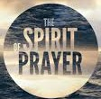.
- Our combined Congregations, and Pastor Dave as we explore this new journey together.
- Everyone that has been affected with Covid-19, and other various illnesses.
*If you have a prayer request, please contact Pastor Dave, church office,
or Prayer Chain Contact Person.

- If you are going to the hospital, having surgery, or have recently been in the hospital, please inform Pastor Dave in one of two ways:
- Call him on his cell phone: 717-466-1216
- Call the Church office and leave a message.
Over the years, I have found that the “greeting line” after worship is not the best way for important information to be shared, due to the limited time available.
-Pastor Dave

Carol Huff
315 Bassett Ct.
Limerick, PA 19468
484-932-8629

Mabel Schultz
Frederick Living
2849 Big Rd.
Apt. 2124B
Zieglersville, PA 19492

June Brinckman
The Village of LifeQuest
2100 Cherry Blossom Lane
Quakertown, PA 18951
215-679-7015

Dorothy Keim
Frederick Living
2849 Big Rd.
Apt. 1229
Zieglersville, PA 19492

Grace Grubb
Pennsburg Manor
Room #214A
530 Macoby St.
Pennsburg, PA 18073
215-679-5030

Howard & Barbara Moser
Frederick Living
2849 Big Rd.
Apt. 116
Zieglersville, PA 19492

Bobby Smith
1491 Markley Rd.
Pennsburg, PA 18073
215-679-9350

Lydia Maurer
502 Main St. Apt. A
East Greenville, PA 18041
215-679-7093

Thelma Borchelt
Frederick Living
2849 Big Rd. Apt. 1302
Zieglersville, PA 19492

Shirley Pursel
134 Concord Dr.
PO Box 155
Hereford, PA 18056-0155
215-679-5644

Janet Kulp
Amity Place #123
139 Old Swede Rd.
Douglassville, PA 19518

Randy & Beverly Reinert
809 Holly Dr.
Green Lane, PA 18054-2022
215-234-8208

Paul Schollenberger
P.O. Box 141
New Berlinville, PA 19545-0141

Peggy Schwenk
Parkhouse Nursing & Rehab Center
1600 Black Rock Rd.
Room #224
Royersford, PA 19468

Lillian Miller
3711 Hershey Ct.
Whitehall, PA 18052-3369

Betty Althouse
159 Main St.
Pennsburg, PA 18073
215-679-8179

Eileen Haring
1828 Big Rd.
Gilbertsville, PA 19525

George Meck
c/o Cindy Palan
1805 Rhawn St.
Philadelphia, PA 19111
215-280-8368

Roy Moll
529 Adams St.
Red Hill, PA 18076-1205
215-679-6650

Pennsburg’s Post
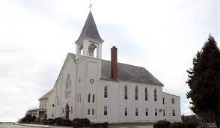
September 2021 Financials; Pennsburg UCC

Beginning Checking Act. Balance $8,975.08
Income $ 2,870.00
Expenses $13,394.35
Transfer from Investments - $5,000.00
Ending Checking Acct. Balance $ 3,450.73

-Sharon Burns/PUCC Treasurer

Pennsburg UCC Congregational Meeting
Pennsburg UCC will be holding the annual congregational meeting on Sunday, November 21st at 11:30. The meeting will be held in Miller Fellowship Hall and lunch will be available.

The Consistory is nominating Holly Lash for a second term.

There are two proposed amendments to the constitution to be voted on:
- Article VI section 1 currently states, "The Consistory shall be the executive body of this Church. It shall be composed of eight to twelve Consistory members, one half plus one shall constitute a quorum for the purpose of doing business. The Pastor or Pastors shall be an ex-officio member of Consistory and all its committees, but they shall have no vote concerning the business conducted at any meetings." The proposed amendment is as follows: "The Consistory shall be the executive body of this Church. It shall be composed of six to eight Consistory members, one half plus one shall constitute a quorum for the purpose of doing business. The Pastor or Pastors shall be an ex-officio member of Consistory and all its committees, but they shall have no vote concerning the business conducted at any meetings."

- Article VI section 3 currently states, "In order to provide continuity of government, not more than four (4) Consistory members shall be elected in any year. Consistory members shall be elected for a term of two (2) years, and they shall be limited to two (2) successive terms in office. Any Consistory member having served two (2) successive terms of two (2) years each shall not be eligible for re-election for a period of one (1) year following completion of their last term of office." The proposed amendment is to remove the first sentence of this section. The adjustment will read as follows: "Consistory members shall be elected for a term of two (2) years, and they shall be limited to two (2) successive terms in office. Any Consistory member having served two (2) successive terms of two (2) years each shall not be eligible for re-election for a period of one (1) year following completion of their last term of office."

Please come out to this important meeting to support the future of our church.
Thank you,
The Members of Pennsburg UCC Consistory
Calvary’s Corner
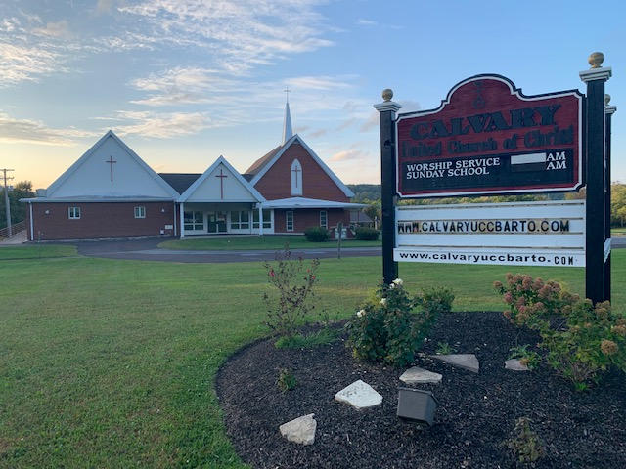
It seems like fall has just begun, and here we are going into November, Thanksgiving and the beginning of Advent. This year is sure going by fast! A lot will be happening at Calvary, so be sure to check out the newsletter!
Pastor Dave is keeping busy with visiting the shut-in’s, attending meetings and getting out in the community. He will be taking part in the Community Thanksgiving Eve Service, hosted this year by Most Blessed Sacrament Catholic Church in Bally. All are invited to attend this special service.
Poinsettia order forms will need to be returned by Dec 5th. Help beautify our church this Christmas! Choices of Red, White or Marble (pink). Poinsettias will be displayed at the Dec 19th service and at the Christmas Eve Service at 4pm on Dec 24th. Poinsettias may be taken home after the Christmas Eve Service.
Mark your calendars for Dec 5, 2021. After our church service, which will include communion, we will hold our Congregational Meeting. Come and get caught up on the happenings at Calvary! Your vote matters! We are still looking for new members for Consistory. Let any consistory member know if you are interested in joining us.
Good news! Audrey Reinhart, Pennsburg UCC’s organist, has agreed to provide live music during the month of November and December, including Christmas Eve at Calvary. Do you play piano? or another instrument? Let us know if you would like to play a special piece for the holidays or any Sunday!
Rona shared that we were able to help a family living in a hotel in Pottstown through our Social ministries. We will give any donations collected at our Free Community Meal in Dec to the Ann Frances Outreach Foundation. We will also be helping the Ann Frances Outreach Foundation by collecting new, unwrapped toys for children ages birth through 16. Please have your donations to church by Dec 5th. Help make this holiday special for these children who could use some cheer!
Kim shared that Kerver Oil will be replacing the circulator on the boiler. Kim will be pricing the cost of a new boiler for the future. Pastor Dave will be checking into our sound system. Thank you, Kim and team for keeping up with our church maintenance. We appreciate all you do!
Thank you for your continued support and generous giving in person, online and mail. We are doing great things in our church and our community thanks to your generosity in giving and volunteering your time and talents. Calvary is Awesome!
As we enter into this holiday season, "Let us come into his presence with thanksgiving; let us make a joyful noise to him with songs of praise!" Psalms 95:2
God Bless,
Your consistory: Harold Albitz, Kim Marburger, Sherry Bauer, Marlene Latshaw, Rona Britton, Becky Crist,
Sonya Spotts and Tracey Frey.
(notice December 5th pops up a lot…..mark your calendars and to do lists!)

