The hands & feet of calvary
United Church Of Christ
November 2022
1231 Route 100, Barto PA 19504
phone # 610-652-5023
Church Office: calvaryucc@gmail.com Website: www.calvaryuccbarto.com
Clothing & Outreach Ministry: calvarysclosetbarto@gmail.com
Join us on FaceBook! Calvary UCC Barto

Dave Brumbaugh, Pastor
Heather Spaccarelli, Administrator
Becky Crist, Consistory President
Linda Himeback, Treasurer

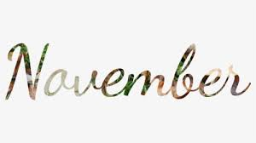

PASTOR'S MESSAGE

We received the deluge of rain for 4 days from the tropical storm Ian, which devastated portions of the Caribbean as well as Florida, the Carolinas, and other inland states with massive wind and water destruction. Our prayers and other resources will help those who lost much, including over 100 lives to know that others care. My brother, who lives in Coral Gables, Florida, said that the devastation is worse than what we have seen on the TV and will take years to rebuild.

On the good side of news, Calvary celebrated our giving heart during the month of Stewardship October, featuring 4 Sundays of highlighting the organizations, foundations, and non-profits with which we partner to help give folks a hand up. Our faith is the catalyst for our actions, and our actions prove that our words have merit. Faith is seen and demonstrated in works. We highlighted Sunday, October 23, with a culmination of our celebration with pianist Ron Stabinsky, gracing us with his playing, folks who are extended “family” of helpers and fellow servants, and some of our young people greeting and ushering. A delicious luncheon, topped off with Marian the Ventriloquist and her friends was the perfect testament to celebrating how God works through the Church by His Spirit. What a talent Marian was for both adults and young people!

Elder Harold Albitz and I attended the Covenant Association Fall meeting at Calvary UCC, Reading. There were 40 pastors and 21 lay person delegates at the meeting. One of the highlights was a presentation by conference staff person, Rev. Cean James, who presented the group with eight (8) keys that growing churches should incorporate into their life, leadership, and goals. I will be meeting with Pastor Cean sometime in November to discuss his thoughts, to let him know what we at Calvary UCC, Barto are doing, and to see how our church might be a model for small churches to follow. It’s not that we have all the answers and have everything ironed out, but I believe that we are on a good track to have growth take place at Calvary – growth in many ways, not just numbers of people.

A recent joy of mine was found in starting our “Explorers” group. So, what is the Explorers group? We are people who are gathering on some Monday nights to “explore” topics in the bible (right now our topic is miracles) and to discuss, question, and seek answers and thoughts about what they mean. Seven people have been gathering to talk about miracles in the bible, and we have been having a great time. The group meets for about 1 ¼ hours.
Our next meeting dates are: Monday, November 14; and Monday, November 21. All are encouraged to attend and you don’t have to attend any gathering beforehand to catch up – every session is independent of the others. Time of the explorers gathering is 6:30 PM – 7:45 PM. Decaf coffee, donuts, cookies and other treats before and after each meeting. Questions? --- call Pastor Dave at 1-717-466-1216 or email: trumpet@dejazzd.com

Hope to see you at Calvary’s special and important November events. Among them are:

  - All Saints Sunday, November 4
  - Veteran’s recognition Sunday, November 13
  - Holiday Bazaar, November 19 – 9 AM – 1 PM(last chances to get your basket raffle tix)
  - Thanksgiving Sunday, November 20
  - Community Thanksgiving Eve worship – Wednesday, November 23 at 7 PM, at Trinity Lutheran Church, Bechtelsville
  - Congregation meeting on Sunday, November 27 after worship (this is also the first Sunday of Advent)

Blessings,
Pastor Dave

___________________________________

11/20 Consistory Meeting, Following Worship

2022 Calvary Consistory Officers

President – Becky Crist
Vice President – Rona Britton
Secretary – Sherry Bauer
Treasurer – Linda Himeback

Elders: Harold Albitz, Sherry Bauer, Kim Marburger, Marlene Latshaw
Deacons: Rona Britton, Tracey Frey, Becky Crist, Sonya Spotts, Linda West

A Note From Calvary’s Consistory…
It seems like fall has just begun, and here we are going into November, cool nights, frost on the pumpkins, with Thanksgiving and Advent just around the corner. This year is sure going by fast! A lot will be happening at Calvary, so be sure to check out this newsletter in its entirety! This year Calvary will be participating in the joint Thanksgiving Eve service which will be held at Trinity Lutheran Church in Bechtelsville. Pastor Dave will be participating and preaching at this service. All are invited to attend this special service on Nov 20th, at 7pm. Please gather for fellowship and refreshments following the service.
Mark your calendars for November 27th. We kick off Advent, lighting the 1st candle and sharing communion. Afterwards we will hold our Congregational Meeting. Come and get caught up on the happenings at Calvary! Your vote matters! We are looking for new members to join Consistory for next year, 2023. Let any consistory member know if you are interested in joining us.
The Ann Frances Outreach Foundation held a successful Gala in our Fellowship Hall and gifted us the new curtains that hang there. Check them out, they look great! We will also be helping the Ann Frances Foundation by collecting new Toys for children ages birth through 16 for Christmas. There will be a collection box in the narthex from November 1st through December 11th. Help make this holiday special for local children who could use some cheer!
Kim shared that Dierolf Water Supply Service was out as our UV Sensor failed, again. They replaced the sensor & module and will monitor it to be sure the problem is fixed. Thanks Kim! Heather is waiting on her new laptop to complete the training needed to get our Online giving option up and running. Hoping to have this all set to go by Advent! Thank you, Heather!
Other News: All Saints day is Nov 6th, Calvary will be an Election Voting place on November 8th, The youth are planning a church bowling outing (more information to come), Veterans will be recognized on Nov 13th , and Poinsettia ordering information will be coming soon.
We want you to know we appreciate all you do! Thank you for your continued support and generous giving in person, and by mail. Many thanks to all who work behind the scenes to keep our flea markets, clothing sales, baked goods, chow-chow sales, and community meals organized and successful events for Calvary. We are doing great things in our church and for our community thanks to your generosity in giving, and volunteering your time and talents.
Calvary is Awesome! As we enter this holiday season, "Let us come into his presence with thanksgiving; let us make a joyful noise to him with songs of praise!" Psalms 95:2
Your consistory,
Becky Crist, Rona Britton, Kim Marburger, Sherry Bauer,
Marlene Latshaw, Linda West, Sonya Spotts, Harold Albitz and Tracey Frey

_______

Pastor Dave Brumbaugh - Worship begins at 9:30am...unless otherwise noted!
Join us in person or via Facebook Live or Zoom!

No computer or smart phone? No problem! You only need a phone to listen to Worship via Zoom!
Dial: 1-646-558-8656 and when prompted, enter the Meeting ID 913 8085 8414 and listen to the voice prompts for simple directions. If you are asked for a password/passcode, enter 848423.

November 2022

November 06 – All Saints Sunday
Remembering Calvary’s past saints and celebrating the resurrection
Scriptures: Ephesians 1:11-23
Message “Heaven is like….”

November 13 – Veteran’s Recognition Sunday
(we invite all veterans who have served in any capacity to join us for this worship service)
Scriptures: Luke 21:5-19
Message “Grace in the Midst of War”

November 20 – Thanksgiving Sunday
Scriptures: Colossians 1:11-20; Luke 23:33-43
Message “Giving Thanks Away”

November 23 – Community Thanksgiving Eve Worship, 7 P.M.
Fellowship and Refreshments will follow worship
*Location: Trinity Lutheran Church, Bechtelsville*
1749 S. Main St. Bechtelsville

November 27* – First Sunday of Advent
Holy Communion
Scriptures: Isaiah 2:1-5; Matthew 24:36-44
Message “Preparing for….”

*Congregation Meeting follows the worship service

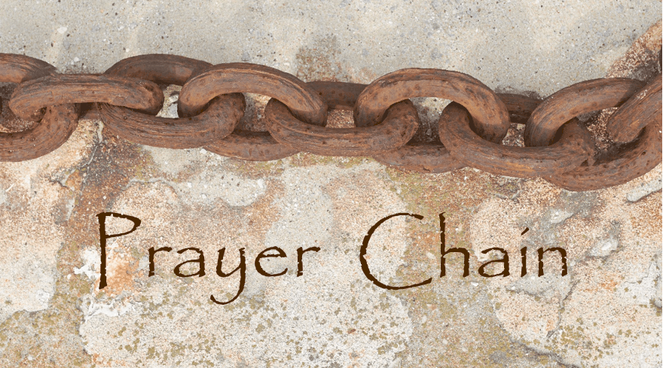
The Prayer Chain is ready to pray for you!
If you need prayers for yourself or a loved one, reach out to Pastor Dave, or the church office and we will send the request through the Prayer Chain.

Election Day is Tuesday November 8th and Calvary is a polling location for Washington Township. Please be aware that the Consistory has come to a decision to not allow any Firearms in the building on this day. Signs will be posted on each entry door to make the public aware of this decision. Any questions may be directed to any Consistory member, or Pastor Dave.

‘EXPLORE MIRACLES’ An exploration of multiple miracles in the bible and in discussion with Pastor Dave. Everyone is welcome on Monday, November 14th and 21st from 6:30 PM – 7:45 PM. What is a miracle? What is their purpose? What does it say about God…and us? Join us in the lower level office area, for snacks and drinks and exploring!
*Please note that there will not be any Exploration group meetings in December due to the busy Christmas season, so come on out on November 14th and 21st, and see what the Explorers group is all about! Please see Pastor Dave with any questions.

Cookie and Pie Baking - Everyone is welcome to join in the fun and fellowship as we prepare cookies and pies for the bazaar on Saturday, November 19.

Here is the baking schedule:

Cookie mixing – Tuesday, November 1st – 4:30 – 5:30 PM
Cookie baking – Thursday, November 3rd – 3:00 – 8:00 PM
Cookie baking – Saturday, November 5th – 7:00 AM – 2:00 PM
Cookie mixing – Monday, November 7th – 4:30 – 5:30 PM
Cookie baking – Thursday, November 10th – 3:00 – 8:00 PM
Cookie baking – Friday, November 11th – 7:00 AM – 2:00 PM
Pie baking – Friday, November 18th – 7:00 AM – 2:00 PM

Annual Holiday Bazaar, Bake Sale, Basket Raffle & *Indoor Flea Market will be held on Saturday November 19th, from 9am to 1pm. The winners of the Basket Raffle will be drawn at the conclusion of the Bazaar at 1pm. *Please note that the Indoor Flea Market doors will open at 7:30am. Many hands will be needed to make this event another success for Calvary.
If you are interested in being a Craft Vendor, kindly pick up an information envelope packet in the Narthex or from the red pedestal mailbox, or you may contact Heather for further information.
*Donations of home-baked-goods are also being accepted to sell at the Bazaar, kindly have them to the church by 5pm on Friday November 18th.

Lunch Bunch! Join us for a lunchtime gathering, at a local restaurant, for conversation, food, and fellowship! Everyone is welcome to attend, just sign up (fellowship board on the ramp) so that the selected restaurant has enough space set aside for our group. Tuesday November 8th, we will meet at Vincezno’s (1333 Old Swede Road, Douglassville) at 11:30am. If you have any questions, please see Kim Yerger.

Toy Drive as the Holiday Season is approaching, Calvary is once again partnering with the Ann Frances Outreach Foundation to help collect Toys! This partnership allows them to help families in the Pottstown area. Help us, help them, help kids to have a brighter holiday season!
New, unwrapped, toys are currently being collected for children ages birth-16 years old. Donations may be left in the box in our greeting area between now and Friday December 11th.
This year the Christmas Wish of the Ann Frances Outreach Foundation is 2,500 toys for over 150 families!
Thank you for your kindness this Holiday season! If you have any questions, please contact Heather in the church office. Thank you!!!
Some ideas of toys that the children really enjoy are:
Trucks, Remote control cars, Hot wheel cars (5 pack), Basketballs, Legos, V-tech learning systems,
Paw patrol, Footballs, Soccer balls, Action figures, Black baby dolls, Black Barbie dolls,
Baby strollers, Crafts, Barbie horses, Blues clues, Scooters
If you would prefer. you can also give a donation at www.AnnFrances.org
Thank you for your love, support, and generosity

* Thank You to everyone that helps promote, volunteer, participates, and
gives their time to make events successful! *

Free Community To-Go Meal & Cold Weather Gear Giveaway is scheduled for Saturday December 3rd from 11am – 1pm. More information will follow soon!

Fall Basket Raffle Thank you to everyone that contributed baskets and items for the baskets.
Tickets will be sold every Sunday morning and at every event through Saturday, November 19.
The drawing will be held following the bazaar at 1:00 PM.

YOU are invited to gather for Coffee and Conversation on Sunday mornings at 8:45 AM in
Calvary’s Fellowship Hall. Everyone is welcome to attend this time of fellowship! If you wish to
provide a breakfast Danish, treat, fruit, or snack kindly sign up on the Fellowship Board (located on the ramp) for a specific date of your choice. Please see Becky Crist or Marlene if you have any questions.

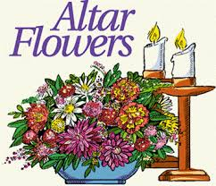
Altar Flower Sponsors are still needed throughout the year…If you wish to sponsor flowers, kindly sign up for a Sunday (or two!) on the poster which is located on the Fellowship board on the ramp. Please indicate for whom you are sponsoring the flowers for along with your name on the poster. Checks may be made out to Tracey’s Flowers. Please see Tracey Frey if you have a special request or for payment questions.

Aluminum Can Collection/Recycling at Calvary Please continue to bring your bagged aluminum cans to the lower double doors and place them in the cans with the blue lids. Thanks for your continued support.

Canning Jars are collected year-round, and saved for chow-chow and our annual Vegetable Soup Sale. You may leave your empty (pint and quart) jars, lids, and bands, at the lower double doors at any time. Thank you for recycling these items to help keep the cost of materials down!
Please remember to swipe your Save-A-Tape card when you check out at Redner’s Markets. The Save-A-Tape card MUST be used for your purchase to be credit to the church’s rebate total. Thanks again to everyone for turning in the tapes. Thank you to Marlene Latshaw for all the organizing and adding!

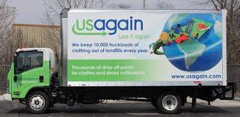
USAgain CLOTHING BINS at Calvary Thank you to all that help to fill our bins and help to reduce, reuse, and recycle clothing materials! Please keep in mind that once bags are dropped into the collection bins, the church has no access to them. So, if you are wanting to donate items to the Flea Market, or to Calvary’s Closet, please drop your items off at the lower doors. Thank you!

Calvary’s Closet…

If you or someone that you know could use a little helping hand with clothing or housewares,
please send an email to: CalvarysClosetBarto@gmail.com

We are currently looking for heavy duty (plastic) utility shelving to be used in Calvary’s Closet and in the Flea Market areas. If you have any that you wish to part with, please contact Rona. We recently received a couple as a donation and they are being put to great use already!

Church News Box at Calvary
This little mailbox on a red pedestal holds copies of monthly newsletters, calendars of events, daily devotional books, and more! If you pick up your newsletter in person, you are invited to pick up your newsletters from this box if you are not able to pick it up while attending Worship.
This mailbox is open anyone!
The red pedestal mailbox is located at Calvary’s lower double doors.

______Notes from the administrator’s desk…______

Heather’s in-building office hours for November: Monday, Wednesday & Friday 4 – 7pm

Moment of Thanks…a HUGE Thank you to the anonymous donor that made purchasing a new, custom-built laptop for the office possible. The previous laptop was just over 3 years old and was hindering the workload in the church office, due to its technology being limited, slow, and outdated. The new laptop arrived the afternoon of Friday October 28th, and the office was without a computer for the entire week until this point. Thank you for your patience with delays over the last few months while we were sorting out the options, and waiting for the laptop to be built.

*The DECEMBER Newsletter Deadline
is Noon on THURSDAY
November 17th*

November Birthdays

11/4 Timothy Frey
11/5 Karen Moatz
11/12 Judy Whitman
11/14 David Schwenk
11/18 Gregory Schoenly
11/19 Constance Eisenhard
11/23 Dorothy Schoenly
11/25 Brenda Fidler, Sandy Shields,
Garnetta Rusinski
11/26 Grace Dotterer
11/28 Deborah Haring
11/29 Eileen Haring
11/30 Sydney Fox, Fred Laquinta

*If you have a Birthday during the month and it was not mentioned, or the date is listed wrong, please let the office know. We are working to keep our records updated and your help in this effort is appreciated. Thank you.

- If you are going to the hospital, having surgery, or have recently been in the hospital, please inform Pastor Dave in one of three ways:
- Call him on his cell phone: 1-717-466-1216
- Email him: trumpet@dejazzd.com
- Call the Church office and leave a message

Mabel Schultz
Frederick Living
2849 Big Rd.
Third floor, room 1311
Zieglerville, PA 19492

Barbara Moser
Frederick Living
2849 Big Rd.
First floor, Apt 1102
Zieglerville, PA 19492
610-652-2263

Paul Schollenberger
P.O. Box 141
New Berlinville, PA 19545-0141
610-367-9655

Thelma Borchelt
Frederick Living
2849 Big Rd. Apt. 1211
Zieglerville, PA 19492
610-652-5115

Janet Kulp
Amity Place Room #123
139 Old Swede Rd.
Douglassville, PA 19518
610-385-9745

Lillian Miller
3711 Hershey Ct.
Whitehall, PA 18052-3369
610-769-7318

Eileen Haring
1828 Big Rd.
Gilbertsville, PA 19525
610-754-6046

Sallie Fronheiser
241 Big Rd.
Bechtelsville, PA 19505
484-944-4504

Please make these updates to your Calvary Membership Directory…

- Jesse Rusinski Jr.
1045 Ruby Circle
Gilbertsville, PA 19525

- George & Katherine Jacob, Jr.
14 Standish Ln.
Hereford, PA 18056
610-702-4221

- Kelly Himeback
1024 Tanglewood Dr.
Carey, NC 27511

- Thelma Borchelt
Frederick Living
2849 Big Rd.
Apt. 1211
Zieglerville, PA 19492
610-652-5115

- Barbara Moser
Frederick Living
2849 Big Rd.
First floor, Apt 1102
Zieglerville, PA 19492
610-652-2263

*If you have an address, phone number, or email update (since February of 2022),
kindly contact Heather in the office.

