News from the pews
of
Calvary And PEnnsburg
United Church Of Christ
“Together for the Greater Good!”
JULY 2021
Calvary United Church of Christ
1231 Route 100, Barto PA 19504
phone # 610-652-5023
Church Office: calvaryucc@gmail.com
Website: www.calvaryuccbarto.com
Join us on FaceBook! Calvary UCC Barto
Clothing Ministry: calvarysclosetbarto@gmail.com

Linda Himeback, Treasurer

Dave Brumbaugh, Pastor
Heather Spaccarelli, Administrator

Pennsburg United Church of Christ
775 Main Street, Pennsburg PA 18073
phone # 215-679-7513
Church Office: pennsburgucc@gmail.com
Website: www.pennsburgucc.org
Join us on FaceBook! Pennsburg UCC

Sharon Burns, Treasurer

PASTOR'S MESSAGE

"May the God of hope fill you all with joy and peace as you trust in Him..." Romans 15:13

Though I will proceed my wife, Brenda, in this move back to Pennsylvania,
we are both looking forward to our return to the Keystone State, and for
my inaugural worship service at Calvary, Barto, for both Churches on
Sunday, July 4, at 9:30 A.M. At the moment, Brenda and I have reserved
an apartment in Royersford, which puts us about 30 minutes or so from
both Churches - not a bad drive considering the insane real estate market
and lack of apartment options. However, we continue to scour the real
estate market within a 45-minute drive of the "farthest" church.

We have an excellent real estate agent whom we have known for 21 years,
and she is an "ace" in keeping a look out for possibilities. Now, on to some
theological reflection...

The above scripture portion from Romans 15:13 reminds us from whom
hope really comes: God. Therefore, we will begin this new adventure together as congregations and designated pastor in a true partnership of hope. God's hope is assured. It is a different hope that the world declares, which may or may not take place. God's hope is certain. Heaven awaits us - that is certain. No matter what we go through in this life, even the worst assault upon our soul, physical, mental, or emotional well-being, God does not change or mitigate love and grace from the people whom he loves - the Church of Jesus Christ. Therefore, we begin our relationship with the strongest hope possible!

I will be working on establishing a regular schedule, as regular as it can be starting a new ministry, sharing office time between Pennsburg and Calvary on different days of the week, or perhaps staggering weeks. I'll negotiate that with both Consistories. So, too, will the days I am working within the 30–35-hour contingency of three-quarter time ministry.

Trusting God through the getting-acquainted time...the exploration time...
the planning time...the hopeful time ahead will take some time and some
careful planning. I ask you all to prayerfully share your prayers, love, and support for my ministry among you, really our ministry together, so that we may bear much fruit, honor God, and have a joyful time doing so!

One other thing - I love to minister to children and youth. So, every worship service at both Churches will include a "Children's Chat" time where I relate something common to life and interest for the children to daily life with God.

Below is my early schedule, sharing office time between churches to begin
my ministry. Exploring the area and beginning to establish relationships
in the wider communities with businesses, leaders, officials, non-profit
helping agencies, and other pastors will take some time as well as visits
and strategic planning for our first year.

In Christ, Pastor Dave
Cell Phone: 717-466-1216
Need something, have a question, share an opinion, prayer concern,
want a visit...etc...please call.

Pastor Dave’s initial office schedule:
July 1 – Thursday – 9:00 A.M. – Noon; 1:00 P.M. – 3:00 P.M. (Barto)
July 2 & 3 – off
July 4 – Sunday worship at 9:30 A.M. (Barto)
July 5 – off
July 6 – Tuesday – 9:00 A.M. – Noon; 1:00 – 3:00 P.M. (Pennsburg)
July 7 – Wednesday – 9:00 A.M. – Noon; 1:00 – 3:00 P.M. (Pennsburg)
July 8 – off
July 9 – Friday – 1:00 P.M. – 5:00 P.M. (Barto)
July 10 – off
July 11 – Sunday worship at 9:30 A.M. (Pennsburg)

7/11 Pennsburg UCC, Consistory Meeting, Following Worship
7/19 Calvary UCC, Consistory Meeting, 7:15pm

Pennsburg UCC Consistory
There are currently two vacancies on the Pennsburg UCC Consistory. We have recently had a consistory member resign. The term for this vacancy will be ending this year in December 2021. The second vacancy is for full term, ending in December 2022. If any of our members are interested in joining consistory in either position, please see any current consistory member.
Thank you,
Pennsburg UCC Consistory

2021 Calvary Consistory Officers
President – Harold Albitz
Vice President – Rona Britton
Secretary – Sherry Bauer
Treasurer – Linda Himeback
Elders: Harold Albitz, Sherry Bauer,
Kim Marburger, Marlene Latshaw
Deacons: Rona Britton, Tracey Frey, Becky Crist, Sonya Spotts

2021 Pennsburg Consistory Officers
President – Jane Bernhard
Vice President – Dana Heimbach
Secretary – Paula Sell
Treasurer – Sharon Burns
Team: Jane Bernhard, Jana Butler, Sharon Burns, Danielle Felix, Dana Heimbach, Bill Kurtz, Holly Lash, Scott Mest, Gail Schmoyer,
Paula Sell, Wendy Smedley

Pastor Dave Brumbaugh - Worship begins at 9:30am.
Join us in person or via Facebook Live or Zoom!

No computer or smart phone? No problem! You only need a phone to listen to Worship via Zoom!
Dial: 1-929-205-6099 and when prompted,
enter the Meeting ID 328 526 4749 and listen to the voice prompts for simple directions.

Pennsburg UCC will host Worship on:
July 11
July 25
Calvary UCC will host Worship on:
July 4
July 18

Updated COVID-19 Precautions at Pennsburg UCC & Calvary UCC
In accordance with new CDC guidelines and recommendations, starting Sunday, June 13th, both Pennsburg UCC & Calvary UCC will no longer be requiring masks for those that have received vaccination for COVID-19. It is still recommended for those without vaccination to continue to wear a mask. In addition, all pews are now open for seating. However, regardless of vaccination status, we ask that you maintain social distancing.

Prayer Chains are ready to pray for you!
If you need prayers for yourself or a loved one, reach out to the church office and we will send
it through the Prayer Chain.

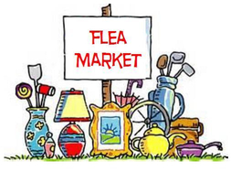

The Pennsburg UCC Flea Market is back this year! It will be held on Saturday July 10 from
8am – 1pm. If you are interested in having a spot at the flea market, please contact Debbie Royer at 215-234-4158. The space is by donation and you may set up at 7am.

The July “First Monday Meal” will be held on July 12, from 6:00 p.m. to 7:00 p.m. at Pennsburg U.C.C. It will be served by The Open Link. The menu is: Hoagies, Pasta Salad, Chips & Dessert.

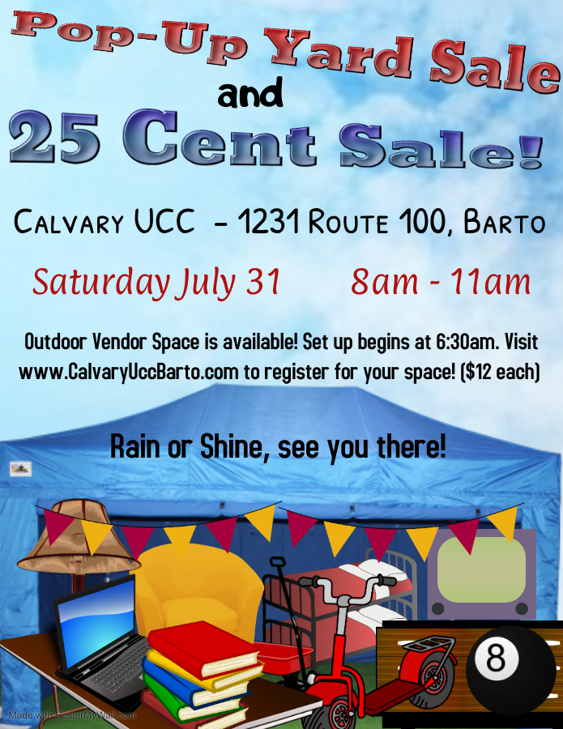

It is time to start thinking about Peaches and Ice Cream!!!!

Pennsburg UCC will be hosting their Annual Peach and Ice Cream Festival
on Saturday August 28 after taking a year off.
In the next few weeks, we will be asking for sign-ups for volunteers for:
peach peeling, serving, set up, and clean up.
We will be having the Basket Raffle, and a sign-up sheet has gone up for basket donations.
Also, this year, we will be asking for monetary donations to help with the cost of the items we need for the preparation of the food. If you would like to donate, please mark your envelope – Peach and Ice cream food.
The festival will go from 4:00-7:30 with the Red Hill Band playing from 5:00-7:00.
We are excited to be able to have our festival again this year, but we will need a lot of help.
If you have any questions, please feel free to contact Dana Heimbach at
dheimbach@perkiomen.org or 267-374-7809.

* Thank You to everyone that helps promote, volunteer, participates, and gives their time to make events successful! *

Vacation Bible School will be held at Pennsburg U.C.C. in cooperation with St. Mark's Lutheran Church from Sunday, July 18 through Thursday, July 22 from 6:30 p.m. to 8:00 p.m. The theme is Group Publishing's "Rocky Railway – Jesus’ Power Pulls Us Through". VBS is available to children from 2 years of age through just completed 6th grade. Please register your child using the registration form (attached to this newsletter) or one available at either Pennsburg U.C.C. or Calvary U.C.C. If you forget to pre-register, you may register on the first night of VBS. At this time, we will be requiring masks and will be holding VBS both inside and outside while observing social distancing. Please have your child bring a beach towel labeled with their name. The towels will be used for them to sit on during our outside activities.
Snack donations are welcome, we are serving individually packaged snacks this year. We are looking specifically for: individually packaged granola bars, Oreo cookies, pretzel sticks, Twizzlers, juice boxes/pouches and bottles of water. These may be placed in the kitchen at Pennsburg U.C.C. We are also looking for volunteers. If you are available to help, or have any questions, please see or call Wendy Smedley at either 610-420-3029 or wsmpucc@aol.com

Chow-Chow Preparation As we begin to prepare for the fall, Chow-Chow will be made on Saturday July 24th beginning at 9am in the kitchen at Calvary. Volunteers are needed to help in the process. Please see Marlene Latshaw if you would like to help!

Something Has Been Missing...
Remember the sound of our church bell ringing every Sunday morning ...
it is a lovely sound and it has been missed.
Aidan Lash took over the Bell Ringer duty but now it is time to pass this “duty”’ on to someone new. Aidan will be going off to college in August. He is willing to teach the bell ringing technique to someone soon.
If you are interested, please contact Kathy Badman or Sharon Burns.

Calvary’s Closet… Here we grow again! Calvary’s Closet is constantly expanding our “network” within the community, and we are looking for a few things to help continue this great success of serving the community!
We are making some exciting changes to the indoor flea market and to Calvary’s Closet.
If you have any of the following items that you wish to donate to the church, please see Rona or Heather to set up a time to bring it by the church, or if needed, picked up. Items that we are currently looking for include, (but not limited to) … Bookshelves, Free-standing coat racks, Sturdy garment & clothing racks, Folding tables, and Card Tables.
*We are also in search of a couch or small sectional, and 2 (non-recliner style) living room chairs. We kindly ask that they please be from a smoke and pet free environment due to allergies. Please contact Rona or Heather if you know of any that are available for low cost or free. Thank you!
With yard sale season upon us, we are always keeping our eyes open for display and storage options,
Thank You for helping us serve the community!

Calvary Altar Flower and Bulletin Sponsors: If you are interested in sponsoring either Altar Flowers or Bulletins for 2021, kindly sign up in the binder located in the greeting area. If you wish to write a check to sponsor flowers, please make it payable to “Tracey’s Flowers” If you choose to write a check for the bulletins, please make it payable to “Calvary UCC” Payments may be placed in the offering plate.

Are you (somewhat) Technically Inclined?
Are you interested in helping with our Facebook Live streaming? Heather is looking for a few people to share the responsibilities and balancing the weight of Sunday morning broadcasts.
Want to help but you’re not available every Sunday morning?
Shaking your head “Yes”? Then this is the perfect opportunity to get involved!
If you would like to help, or want more information, please contact Heather at calvaryucc@gmail.com, or call Calvary’s office. She is looking forward to hearing from you!

Aluminum Can Collection/Recycling at Calvary Please bring your bagged aluminum cans to the lower double doors and place them in the cans with the blue lids. Thanks for your support.

Are you wanting to help, but unsure how?
As Community Outreach grows at Calvary, so does the need of helping hands. Currently the needs are very basic jobs, such as placing clothing on a hanger and placing books on a shelf. If you have some time, even an hour to spare during the week, please see Rona, Heather, or Kim Marburger to volunteer. Any help is appreciated! Thank you for your continued support in this awesome endeavor!

FOR SALE!

GT 235 (2001) with a 42” Deck, Green. Works. Moderate Cosmetic Issues.
Owner’s manual available.
Asking $400
(The riding mower has been used in the Pennsburg UCC Cemetery, and is no longer needed since a landscape service now maintains the grounds.)
Please Contact Donna Falk, 215-679-5933 if interested.

Church News Box at Calvary
This little mailbox on a red pedestal holds copies of monthly newsletters, calendars of events, daily devotional books, and more! If you pick up your newsletter in person, you are invited to pick up your newsletters from this box if you are not able to pick it up while attending Worship.

This mailbox is open to BOTH congregations, and also the public!
The red pedestal mailbox is located at Calvary’s lower double doors.

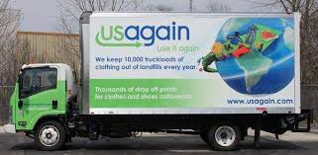
USAgain CLOTHING BINS at Calvary Thank you to all that help to fill our bins and help to reduce, reuse, and recycle clothing materials! Please keep in mind that once bags are dropped into the collection bins, the church has no access to them. So, if you are wanting to donate items to the Flea Market, or to Calvary’s Closet, please drop your items off at the lower doors. Thank you!!

Notes from the administrator’s desk…

Office hours at Calvary are as follows:
Monday, Wednesday, Friday 4pm – 6pm Tuesday & Thursday 8:30am – 12:30pm
At this time, Office hours at Pennsburg are Flexible, reach out to Heather if you wish to stop by.

*The AUGUST Newsletter Deadline is Noon on Wednesday JULY 21st*

JuLY BIRTHDAYS

7/1 Tom May
7/2 Monica Kurtz & Lynsie Stofflet
7/3 Taylor Smith & Katherine Jacob
7/4 Michael Borchelt & Carl Heffner
7/8 Jackie Lauchnor
7/9 Sherry Bauer, Matthew Frey & Katie Latshaw
7/10 Barbara Moser
7/13 Earl Brey & Grant Fronheiser
7/16 Elizabeth Royer
7/17 Paul Seip
7/18 Becky Crist
7/19 Fay Czarnecki & Ruth Nice
7/20 Dorothy Borchelt
7/21 Grant Beard & Blaine Ruth
7/22 Emma Felegie & Justin Freed
7/25 Carol Kuzmission
7/27 Brenda Schoenly
7/28 David Bickley
7/29 Derek Lash & Linda Zilinski
7/30 Paul Mathias

*If you have a Birthday during the month and it was not mentioned, or the date is listed wrong, please let the office know. We are working to keep our records updated and your help in this effort is appreciated. Thank you.

July Anniversaries

7/19 – Suzanne & Michael Cleary
7/29 – Estella & Glenn Beard

*If you have an Anniversary during the month and it was not mentioned, or the date is listed wrong, please let the office know. We are working to update our records and your help in this effort is appreciated. Thank you.

- Please hold our future Interim Pastor, Dave Brumbaugh, in prayer as God prepares him
for ministry with us.
- Everyone that has been affected by the Pandemic and illness.
*Please contact the Prayer Chains, or Pastor Dave with any additional Prayer Requests

Carol Huff
315 Bassett Ct.
Limerick, PA 19468
484-932-8629

Mabel Schultz
Frederick Living
2849 Big Rd.
Apt. 2124B
Zieglersville, PA 19492

June Brinckman
The Village of LifeQuest
2100 Cherry Blossom Lane
Quakertown, PA 18951
215-679-7015

Dorothy Keim
Frederick Living
2849 Big Rd.
Apt. 1229
Zieglersville, PA 19492

Grace Grubb
Pennsburg Manor
Room #214A
530 Macoby St.
Pennsburg, PA 18073
215-679-5030

Howard & Barbara Moser
Frederick Living
2849 Big Rd.
Apt. 116
Zieglersville, PA 19492

Bobby Smith
1491 Markley Rd.
Pennsburg, PA 18073
215-679-9350

Emil Schultheisz
120 W. 5th St.
Chestnut Knoll Room 313
Boyertown, PA 19512

Lydia Maurer
502 Main St. Apt. A
East Greenville, PA 18041
215-679-7093

Thelma Borchelt
Frederick Living
2849 Big Rd. Apt. 1302
Zieglersville, PA 19492

Shirley Pursel
134 Concord Dr.
PO Box 155
Hereford, PA 18056-0155
215-679-5644

Janet Kulp
Amity Place #123
139 Old Swede Rd.
Douglassville, PA 19518

Randy & Beverly Reinert
809 Holly Dr.
Green Lane, PA 18054-2022
215-234-8208

Paul Schollenberger
P.O. Box 141
New Berlinville, PA 19545-0141

Peggy Schwenk
Parkhouse Nursing & Rehab Center
1600 Black Rock Rd.
Room #224
Royersford, PA 19468

Lillian Miller
3711 Hershey Ct.
Whitehall, PA 18052-3369

Betty Althouse
159 Main St.
Pennsburg, PA 18073
215-679-8179

Eileen Haring
1828 Big Rd.
Gilbertsville, PA 19525

George Meck
c/o Cindy Palan
1805 Rhawn St.
Philadelphia, PA 19111
215-280-8368

Roy Moll
529 Adams St.
Red Hill, PA 18076-1205
215-679-6650
Pennsburg’s Post
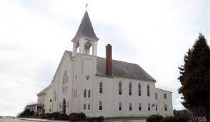
Updates from PUCC Treasurer - Sharon
Anyone notice a difference in your offering envelopes?
There will no longer be a separate envelope for Cemetery donations. Instead, there is now a line on the weekly envelope for Cemetery donations.
These donations will be given to PUCC Cemetery for the upkeep of the Cemetery, as always.
If, at any point, you do not need to receive or use the offering envelopes, notify the PUCC Admin to remove you from the mailing list. Any donations will be credited to you, if your name is attached, with or without the official offering envelopes.
Questions, ask me.
Back in April of 2020, the UCC PA Southeast Conference gave every church in our conference $1,000.00 to be used for expenses during time during Covid that our churches were not worshipping in person. If your church felt that they would not need this money, a church could decide to regift it to another congregation that might need it. New Goshenhoppen regifted their Rainy Day $1,000 check to PUCC. At the same time, PUCC’s consistory made the decision to place our $1,000 in the Special Gift account to save it for a person or persons that might need financial help due to the pandemic. The donation from New Goshenhoppen was also placed in this account to be given to someone in need. In the past year’s newsletter, there was always a note asking if anyone needed help. Fortunately, no one needed help. At PUCC’s June 2021 Consistory meeting, it was voted that this money, $2,000.00, be sent to PSEC designated to be used for the UCC Special Missions Offerings, $500 each to One Great Hour of Sharing, Strengthen the Church, Neighbors In Need and the Christmas Fund, along with our monthly donation of $417.00 to OCWM.
New Goshenhoppen was notified of how their gift was being used.
Lastly, I have not published our financial info the past few months. Below is a recap.
I would like to THANK everyone who kept sending your donations by mail as well as the Sunday morning offerings.
January 1, 2021 Checking Account Balance - $5,620.92
May 31, 2021 Checking Account Ending Balance - $5,898.50
Total Deposits - $25,852.63
Total Expenses - $25,575.05
Total Investment Amount transferred into Checking Account from 1-1 to 5-31-21 -$ .00
As we end our Supply pastor time and enter into a shared 3/4 time ministry, our expanses will increase.
Again, questions, please ask me. Thank you, Sharon Burns
Calvary’s Corner
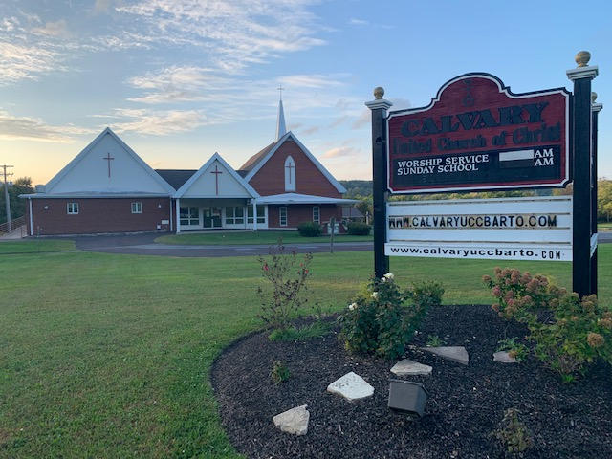
Happy July! The month we celebrate our Independence as a country, enjoy picnics, pool time, vacations and………The arrival of Pastor David Brumbaugh! Please feel free to contact the church to speak with Pastor Dave if you have a pastoral need or just to say welcome. We will be planning a welcome event in the future as restrictions are lifted, so please introduce yourself and wear a provided name tag so Pastor Dave can begin to gets to know us at services. Pastor Dave is excited and looking forward to joining our shared ministry.

Both Calvary and Pennsburg will continue to make our services available through Zoom and Facebook. So, check out Pastor Dave online if you will be away this summer. Please contact the church office if you have any questions. We look forward to seeing you in person or online
throughout the summer.

Thank you for your continued support and generous giving in person, online and mail. Our Calvary family is Awesome! We continue to be blessed, especially entering a new pastorship. Calvary is not a building; it is the people of Calvary who keep Calvary’s ministry alive and strong. Thank you!!

Another, thank you to all who work endless hours to pull together our clothing and flea market sales and keep it all organized! Our Church remains a strong presence in our community through our Events, Free Meals, and Clothing giveaways - as well as our ability to support the homeless and needy.

Rona shared that our A.E.D. unit is up to date, and Kim reported that the new UV light unit has been installed.

Congratulations to all our graduates on your achievements and accomplishments! We were able to celebrate with Becky Marburger, Matthew Frey and Katie Latshaw on Father’s Day as they joined us for church. We wish all our graduates the very best as they spread their wings.
May you feel the Lord’s blessings every day. As Pastor Megan suggested, begin and end everyday with the words, I am Blessed, then enjoy the warmth of God’s love as it surrounds you.

Your consistory Harold Albitz, Kim Marburger, Sherry Bauer, Marlene Latshaw, Rona Britton, Becky Crist, Sonya Spotts and Tracey Frey.

St. Mark’s Lutheran Church / Pennsburg U.C.C.

VACATION BIBLE SCHOOL
July 18 – July 22, 2021
Sunday - Thursday
6:30 – 8:00 p.m.
(Sunday Registration – 6:15 p.m.)
Note: Children may leave earlier, if
necessary, with parent/guardian.

**Location: Pennsburg United Church of Christ
775 Main Street
Pennsburg, PA 18073

“Rocky Railway – Jesus’ Power Pulls Us Through”
Children ages 2 to just completed 6th grade are invited to participate.
Children age 3 or under must be accompanied by an adult.
Donations of juice boxes or pouches, bottles of water and pre-packaged snacks. Donations can be dropped off just before or during Vacation Bible School. Adults who would like to help out are always welcome! Children are urged to dress comfortably and wear a mask. Social distancing will be observed and children will be urged to sit with family/household members. Please bring a beach towel per child.

Please complete the attached Enrollment Form and return to St. Mark’s, attention Dawn or Pennsburg
U.C.C., attention Wendy as soon as possible to reserve a spot.
ST. MARK’S / PENNSBURG U.C.C. VBS ENROLLMENT FORM
Name__________________________ Age________ Birth Day___________
Address________________________________________________________
Phone Number_______________________ Grade Completed_______________
Parent’s Names___________________________________________________
Who May Pick Up Your Child?_________________________________________
Emergency Contact Name(s)__________________________________________
Emergency Contact Phone #(s)________________________________________
Food Allergies____________________________________________________
Other Helpful Information___________________________________________
_______________________________________________________________
Do You Have A Church Home? Yes_______ No________
Comments_______________________________________________________

I give my permission for ___________________________________ to attend Rocky Railway VBS, July 18 to 22, 2021. In the event of medical emergency, I authorize VBS Staff to seek medical attention for my child, I will assume responsibility for any/all resultant expense. Every attempt will be made to notify the parent or emergency contact first.
__________________________________
Parent/Guardian Signature & Date

